PowerLock Data Sheet and Programmers Reference

Preliminary Data
This preliminary data sheet is for review only. The manufacturer reserves the right to change characteristics without notice.

General
The 5-wire PowerLock interface supports LIN BUS.

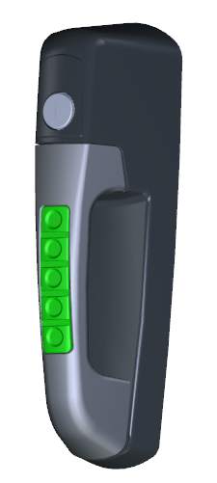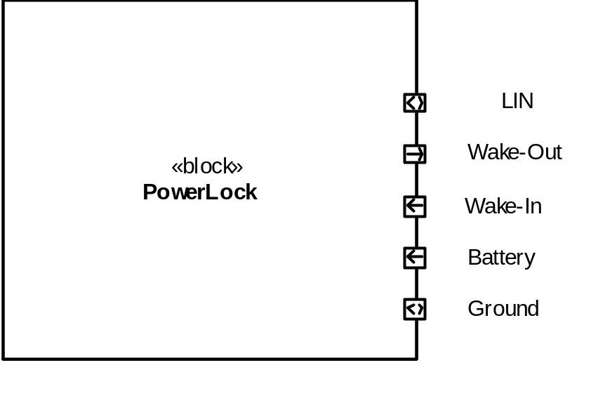

Electrical Ratings
Ratings are based on characterization of components and should be verified in end-use environment.
All voltages with respect to Ground (unless otherwise noted);

Pos | Parameter | Symbol | Limit Values |  | Unit | Remarks
Pos | Parameter | Symbol | Min | Max | Unit | Remarks
Voltages
1 | Un-switched Battery | Battery (VBat)  BatteryMAX  BatteryJUMP  BatteryOPER  BatteryOFF | -56  -  9  0 | 56  36  32  3 | V  V  V  V | Load Dump  Jump Start 5 min  Operating range  Device in reset/off
2 | Wake-In  Active Wake-In  Inactive Wake-In | Wake-In  Wake-InMAX  Wake-InH  Wake-InL | -40  +4.0  -40 | 40  40  1.6 | V  V  V | Max without damage  Actively wakes device  Does not wake device
3 | Wake-Out  Active Wake-Out  Inactive Wake-Out | Wake-Out  Wake-OutH  Wake-OutL | >7  0 | VBat  0.2 | V  V | Wake-Out does not have active pull-down.
6 | LIN BUS | LINMAX  LINREC  LINACT | -40  Vs x 0.8  - | 40  Vs  Vs x 0.2 | V  V  V | External fault applied  Recessive  Active
Currents
1 | Module Current  Nominal  Low Power  Un/Lock Active | IBATTERY  IBATTERY-NOM  IBATTERY-LOW  IBATTERY-ACT | 2  -  1.5 | 20  0.7  4 | mA  mA  A | Operating  Sleep Mode  During Un/Lock pulse
2 | Current on Wake-In | IWAKE-IN | 0.1 | 10 | mA | 26v applied to pin
3 | Wake-Out Output Current | IWAKE-OUT  IWAKE-OUT-ACT  IWAKE-OUT-OFF | 0.7  - | 2.4  7 | A  uA | self limited  leakage current
Temperature
 | Operating | TOPER | -40 | +85 | °C
 | Storage | TSTORAGE | -40 | +125 | °C
 | Exceptions | Acoustic Signal |  |  |  | Part Rating
 |  | Motor |  |  |  | Part Rating
Timing
 | Tolerance | Timing-NOM | -1 | +1 | % | At 25 °C
 |  | Timing-TEMP | -5 | +5 | % | -40°C to +85°C

Programmers Reference
The following information may aid in the software development for this module and is supplemental information to the IO Allocation data in an Excel workbook.

Any pin references are referring to the pin number on the micro itself.

Time Base
The project does not utilize a crystal oscillator for a time-base. It uses the internal oscillator, which has some drift over time and temperature. For all timing calculations, the tolerance of this should be taken into account. LIN packets start with a single byte that is 0x55 (or maybe it is 0xAA), and this is often used to auto-baud.

Battery Sense (pin 2)
Battery sense is on Analog channel 0. This pin is also C12IN0-, which permits use of the internal comparator to shut-down the high-voltage supply in either software (by reading the analog) or hardware (by using the comparator).

HV Enable (pin 6)
RA4 is also C1OUT, which is an internal analog comparator. When high, this pin enables the high-voltage power supply for the motor. This supply should be disabled to minimize power consumption and as a protection in over-voltage conditions. The recommendation is to use the internal Digital to Analog to set the threshold to auto-off the HV supply under high voltage conditions.

Hi Voltage Threshold (pin 5)
Ideally, this signal is not used and the components will not be populated. If the internal d-to-a is insufficient in its ability to configure the high voltage shutdown, then we may need to set the threshold from this external source. An external divider sets the threshold and the software will configure it against the Battery Sense signal.

Wake Input (pin 3)
This is wired to a pin that is both an analog input and can be configured on a comparator input for generation of a hardware wakeup event.

Learn Input (pin 4)
Learn mode is an input pin - active high would indicate Learn Mode. All other behavior is defined in Software.
Learn mode is wired to an analog input for additional flexibility.

Wake Output (pin 18)
This is used as a standard port pin, where an active high enables the wake output driver to energize the Wake Out pin in the harness.

Power Control (pin 24)
This signal may not be required. Depending on the hardware design, this pin would maintain the internal power supply that keeps the micro awake.

Backlight Control (pin 17)
Capture Compare 2 can provide a PWM drive. Recommended frequency is anywhere from 200 to 1000 Hz.

Power Supply final design will determine where the LEDs power source comes from.

If sourced from a fixed internal power supply, then the hardware will be designed to not over-stress the LEDs drive current.

If sourced from the main battery, then the software must manage the LEDs to avoid over-driving them. This is necessary to get the appropriate drive at the low voltage end and limit the drive at the high end of the range, in which case the follow applies.

CAUTION: In order to support an operating range from 9 to 32 v and attain appropriate backlight brightness at the low end, it is possible to over-drive the LEDs. Therefore it is important to keep the PWM under control as a function of the battery input voltage.

The full brightness calculation should be:

% PWM = 9.0 / VBattery * % Desired Brightness

The %PWM is then converted to the appropriate capture compare register value.

H-Bridge (pins 12, 13)
These pins are H-Bridge Phase-A and Phase-B, which are used to power the motor in either forward or reverse.
The pins are also PWM capable, which may be required – depending on the power supply design.

H-Bridge Status (pin 11)
This is a port pin that can be used to monitor the H-Bridge driver for fault detection. See the specification for the H-Bridge driver chip.

KeyPad (pins 23, 25, 26, 27, and 28)
Keypad consists of 5 port pins that are pulled low when the key is pressed.

Pin 23 is INT2 and can be used to wake up the micro from a sleep state. The remaining pins have the IOC capability and can also be used, but require different configuration to activate.

Acoustic Signal (pin 21)
This is a port pin that when driven high causes the acoustic signal to energize.

LIN (15, 16, 22)
LIN has hardware support in the UART module and is connected to pins 15 and 16. Pin configuration is necessary to activate LIN on these pins.
The internal UART has an auto-baud detection mechanism designed for LIN.
The LIN chip is enabled when pin 22 is set high.
The pin-out does not match the Lin Evaluation board that Microchip offers.

Overvoltage Power Management
Design Notes: As noted above, the battery voltage can be measured and it can control a HV Enable pin. In order to manage the overall power dissipation of the system, the following subordinate requirements shall be supported.

Load Dump
350 ms +/- 30 %
<= 10 ms
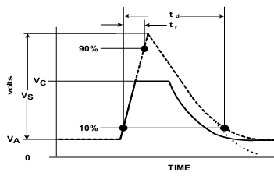
202v (28v + 174v)
56v clamped by Alternator
28v
Figure 35 from JDQ 53.3 (there appears to be an error; V_{A} should be labeled V_{B})

Table 54 from JDQ 53.3
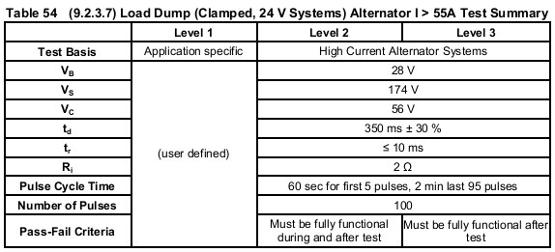

High Voltage Control
At a system voltage of BatteryJUMP or higher, the HV Enable shall be set low to disable the switching supply. This may be done by hardware configuration of the comparator, by via software. Further, the drive signals for the following subsystems shall be disabled or turned off.
- H-Bridge to the Motor.
- LEDs turned off.

Logic Supply Power Control
Design Notes: The logic regulator is a linear regulator, and if left unmanaged could reach its power dissipation limit. Active management for this consists of controlling the PIC average current drain to a value below 2 mA.

As the system is not required to operate, it is permissible to control a number of behaviors including reducing or stopping the clock (so long as recovery is automatic when the voltage drops).

Reference Documents
The following documents and referenced sections are applicable to this design.
Document | Section | Description
JDQ 53.3 |  | Level 3 Device Requirements
JDQ 53.3 | 9.2.3.10 | Test Pulse for Clamped load dump

