Power Lock Data Sheet and Programmers Reference

Preliminary Data Sheet

This preliminary data sheet is for review only.
The manufacturer reserves the right to change characteristics without notice.

General
The 5-wire Power Lock interface supports LIN BUS.

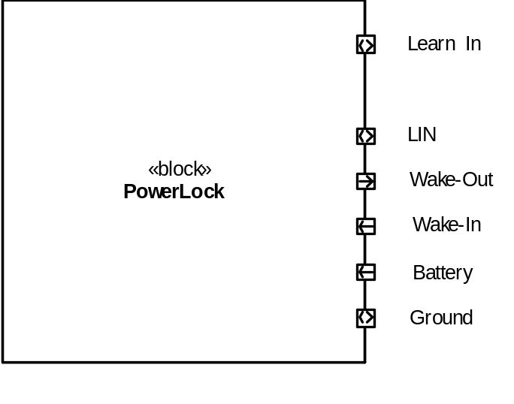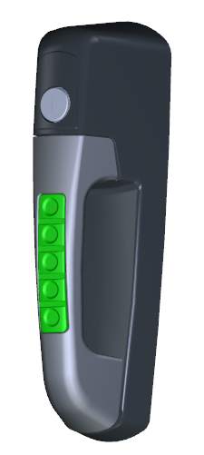

Electrical Ratings
Ratings are based on characterization of components and should be verified in end-use environment.
All voltages with respect to Ground (unless otherwise noted);

Pos | Parameter | Symbol | Limit Values |  | Unit | Remarks
Pos | Parameter | Symbol | Min | Max | Unit | Remarks
Voltages
1 | Un-switched Battery | Battery (VBat)  BatteryMAX  BatteryJUMP  BatteryOPER  BatteryOFF | -56  -  10  0 | 60  36  32  6 | V  V  V  V | Load Dump  Jump Start 5 min  Operating range  Device in reset/off
2 | Wake-In  Active Wake-In  Inactive Wake-In | Wake-In  Wake-InMAX  Wake-InH  Wake-InL | -40  +4.0  -40 | 40  40  1.6 | V  V  V | Max without damage  Actively wakes device  Does not wake device
3 | Wake-Out  Active Wake-Out  Inactive Wake-Out | Wake-Out  Wake-OutH  Wake-OutL | >VBat – 2  - | - | V  V | Wake-Out does not have active pull-down.
6 | LIN BUS | LINMAX  LINREC  LINACT | -40  Vs x 0.8  - | 40  Vs  Vs x 0.2 | V  V  V | External fault applied  Recessive  Active
Currents
1 | Module Current  Nominal  Low Power  Un/Lock Active | IBATTERY  IBATTERY-NOM  IBATTERY-LOW  IBATTERY-ACT | 2  -  1.0 | 20  0.7  2.5 | mA  mA  A | Operating  Sleep Mode  During Un/Lock pulse
2 | Current on Wake-In | IWAKE-IN | 4  8 |  | mA  mA | Contact wetting current  12v applied to pin  24v applied to pin
3 | Wake-Out Output Current | IWAKE-OUT  IWAKE-OUT-ACT  IWAKE-OUT-OFF | 0.2  - | 100 | A  µA | self-limited  leakage current
Temperature
 | Operating | TOPER | -40 | +85 | °C
 | Storage | TSTORAGE | -55 | +105 | °C | JDQ53.3 Level 2
Temperate Exceptions
 | Mallory PK-12N40PQ | Acoustic Signal | -20 | +90 | °C | Operating Temp Range
 | Mallory PK-12N40PQ | Acoustic Signal | -30 | +100 | °C | Storage Temp Range
 | Mabuchi  FC280SC-20150 | Motor | -30 | +80 | °C | Component Rating
Timing
 | Tolerance | Timing-NOM | -1 | +1 | % | At 25 °C
 |  | Timing-TEMP | -5 | +5 | % | -40°C to +85°C

Document Versions
This document is aligned to SCH_11377 rev 1.0 schematic.

Programmers Reference
The following information may aid in the software development for this module and is supplemental information to the IO Allocation data in an Excel workbook.

Any pin references are referring to the pin number on the micro unless otherwise noted.

Time Base
The project does not utilize a crystal oscillator for a time-base. It uses the internal oscillator, which has some drift over time and temperature. For all timing calculations, the tolerance of this should be taken into account. LIN packets start with a single byte that is 0x55 (or maybe it is 0xAA), and this is often used to auto-baud.

Supply Voltage (pin 20)
Power in to the micro itself is nominally 3.3v, with a 1% tolerance based on the regulator. This is the reference for the internal A/D as well.

Battery Sense An (pin 2)
Battery Sense is on Analog channel 0. This pin is also C12IN0-, which permits use of the internal comparator to shut-down the high-voltage supply in either software (by reading the analog) or hardware (by using the comparator).
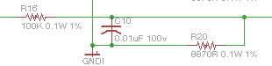
V(a/d) = Battery * 8870/(100000 + 8870)

HV Enable L (pin 6)
High Voltage Enable Logic output (RA4) is also C1OUT, which is wired to an internal analog comparator. When high, this pin enables the high-voltage power supply for the motor, acoustic signal, and the keypad LEDs. This supply should be disabled to minimize power consumption and as a protection in over-voltage conditions. The recommendation is to use the internal Digital to Analog to set the threshold to auto-off the HV supply under high voltage conditions (e.g. Load Dump).

HV Power Good (pin 10)
High Voltage Power Good is an active high logic input signal that indicates that the HV supply is >= 90% of the configured voltage.

HV Shutdown Level (pin 5)
High Voltage Shutdown Level is wired to a pin that is both an analog input, and an input to an internal comparator which permits the hardware to be configured to automatically shut down the high voltage (using the Hi Voltage Enable Logic output).

Ideally, this signal is not used and the components will not be populated. If the internal d-to-a is insufficient in its ability to configure the high voltage shutdown, then we may need to set the threshold from this external source. An external divider sets the threshold and the software will simply configure it against the Battery Sense Analog signal to control the HV Enable Logic output.

Wake In An (pin 3)
Wake Input Analog it wired to a pin that is both an analog input and can be configured on a comparator input for generation of a hardware wakeup event. Wake In is an active-high signal.

Learn In An (pin 4)
Learn Input Analog - active high would indicate Learn Mode. All other behavior is defined in Software. By designing for an active high to enable, a harness fault that grounds this pin does not inadvertently enable learn mode.

Wake Output L (pin 15)
Wake Output Logic is connected to a standard port pin, where an active high enables the wake output driver to energize the Wake Out pin in the harness.

Backlight Enable L (pin 16)
Backlight Enable Logic output pin is used as an active high logic output to turn on the LEDs.

The hardware design will limit the current to the LEDs, so this pin can be set from 0 (full off) to logic 1 (full on).

It may be possible to dim the LEDs by using the SPI port this is connected to and streaming a value (e.g. 0xAA for 50%). It must be assessed if this can be done without disturbing the related pins (SDI, SCK).

H-Bridge Phase A, B (pins 12, 13)
H-Bridge Phase-A and Phase-B, respectively, which are used to control the motor with the possibilities of forward, reverse, brake, or coast.

The power supply design is such that the motor is driven from a switching 12v supply which must be enabled prior to activation of the H-Bridge, after which these can be operated as simple logic output signals.

The motor has not been characterized over the temperature range; however a simple “pulse” on the order of 250 msec is likely to be sufficient. This timing value should be adjustable via diagnostics and stored in non-volatile memory.

H-Bridge Status (pin 11)
H-Bridge Status is a port pin that can be used to monitor the H-Bridge driver for fault detection. See the specification for the H-Bridge driver chip.

Key #-# L (pins 21, 22, 23, 25, and 26)
Keypad #-# Logic input consists of 5 port pins that are pulled low when the corresponding key is pressed.

Pins 21, 22, and 23 are INT0, INT1, and INT2, and can be used to wake up the micro from a sleep state.

Pints 25 and 26 are KBI0 and KBI1 and have IOC capability which can also wake up the micro, but require different configuration to activate.

Acoustic Enable L (pin 24)
The Acoustic Enable Logic output is an active high port pin that will turn on the acoustic signal. The acoustic signal is self-oscillating, so simple on/off logic can be used.

LIN Tx, Rx (pins 17, 18)
LIN Transmit and Receive has hardware support in the UART module. Pin configuration is necessary to activate LIN on these pins.
The internal UART has an auto-baud detection mechanism designed for LIN.

LIN En (pin 14)
The LIN Enable is an active high signal to enable the LIN transceiver.

NOTE: The pin-out does not match the Lin Evaluation board that Microchip offers.

Overvoltage Power Management
Design Notes: As noted above, the battery voltage can be measured and it can control a HV Enable pin. In order to manage the overall power dissipation of the system, the following subordinate requirements shall be supported.

Load Dump
350 ms +/- 30 %
<= 10 ms
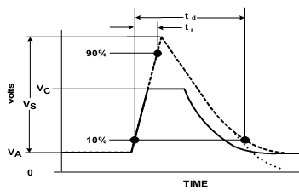
202v (28v + 174v)
56v clamped by Alternator
28v
Figure 35 from JDQ 53.3 (there appears to be an error; V_{A} should be labeled V_{B})

Table 54 from JDQ 53.3
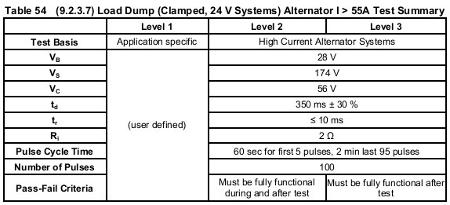

High Voltage Control
At a system voltage of BatteryJUMP or higher, the HV Enable shall be set low to disable the switching supply. This may be done by hardware configuration of the comparator, by via software. Further, the drive signals for the following subsystems shall be disabled or turned off.
- H-Bridge to the Motor.
- LEDs turned off.

Logic Supply Power Control
Design Notes: The logic regulator is a linear regulator, and if power consumption is unmanaged it could reach its power dissipation limit. Active management for this consists of controlling the average current drain for the PIC and peripheral components (e.g. shutting down diagnostic LEDs, sleep mode, etc).

As the system is not required to operate in over-voltage conditions, it is permissible to control a number of behaviors including reducing or stopping the clock (as long as recovery is automatic when the voltage drops).

Reference Documents
The following documents and referenced sections are applicable to this design.
Document | Section | Description
JDQ 53.3 |  | Level 3 Device Requirements
JDQ 53.3 | 9.2.3.10 | Test Pulse for Clamped load dump

