Power Lock Data Sheet and Programmers Reference
Preliminary Data Sheet

This preliminary data sheet is for review only.
The manufacturer reserves the right to change characteristics without notice.

General
The 5-wire Power Lock interface supports LIN BUS.

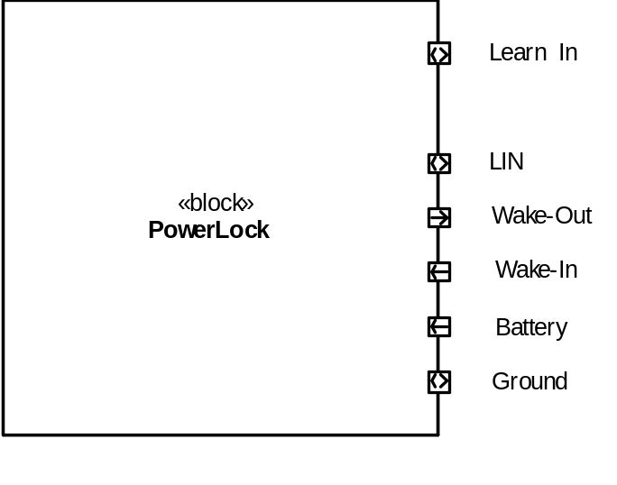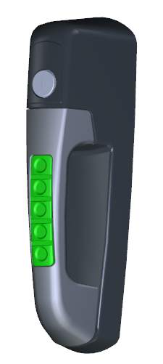

Reference Documents
The following documents and referenced sections are applicable to this design.
Document | Section | Description
SCH_11377 | v1.0 | Schematic
JDQ 53.3 |  | Level 3 Device Requirements
JDQ 53.3 | 9.2.3.10 | Test Pulse for Clamped load dump

Electrical Ratings
Ratings are based on characterization of components and should be verified in end-use environment.
All voltages with respect to Ground (unless otherwise noted);

Pos | Parameter | Symbol | Limit Values |  | Unit | Remarks
Pos | Parameter | Symbol | Min | Max | Unit | Remarks
Voltages
1 | Un-switched Battery | Battery (VBat)  BatteryMAX  BatteryJUMP  BatteryOPER  BatteryOFF | -56  -  10  0 | 60  36  32  6 | V  V  V  V | Load Dump  Jump Start 5 min  Operating range  Device in reset/off
2 | Wake-In  Active Wake-In  Inactive Wake-In | Wake-In  Wake-InMAX  Wake-InH  Wake-InL | -40  +4.0  -40 | 40  40  1.6 | V  V  V | Max without damage  Actively wakes device  Does not wake device
3 | Wake-Out  Active Wake-Out  Inactive Wake-Out | Wake-Out  Wake-OutH  Wake-OutL | >VBat – 2  - | - | V  V | Wake-Out does not have active pull-down.
6 | LIN BUS | LINMAX  LINREC  LINACT | -40  Vs x 0.8  - | 40  Vs  Vs x 0.2 | V  V  V | External fault applied  Recessive  Active
Currents
1 | Module Current  Nominal  Low Power  Un/Lock Active | IBATTERY  IBATTERY-NOM  IBATTERY-LOW  IBATTERY-ACT | 2  -  1.0 | 20  0.7  2.5 | mA  mA  A | Operating  Sleep Mode  During Un/Lock pulse
2 | Current on Wake-In | IWAKE-IN | 4  8 |  | mA  mA | Contact wetting current  12v applied to pin  24v applied to pin
3 | Wake-Out Output Current | IWAKE-OUT  IWAKE-OUT-ACT  IWAKE-OUT-OFF | 0.2  - | 100 | A  µA | self-limited  leakage current
Temperature
 | Operating | TOPER | -40 | +85 | °C
 | Storage | TSTORAGE | -55 | +105 | °C | JDQ53.3 Level 2
Temperate Exceptions
 | Mallory PK-12N40PQ | Acoustic Signal | -20 | +90 | °C | Operating Temp Range
 | Mallory PK-12N40PQ | Acoustic Signal | -30 | +100 | °C | Storage Temp Range
 | Mabuchi  FC280SC-20150 | Motor | -30 | +80 | °C | Component Rating
Timing
 | Tolerance | Timing-NOM | -1 | +1 | % | At 25 °C
 |  | Timing-TEMP | -5 | +5 | % | -40°C to +85°C

