PowerLock Programmers Manual

General
The 5-wire Power Lock interface supports LIN BUS.

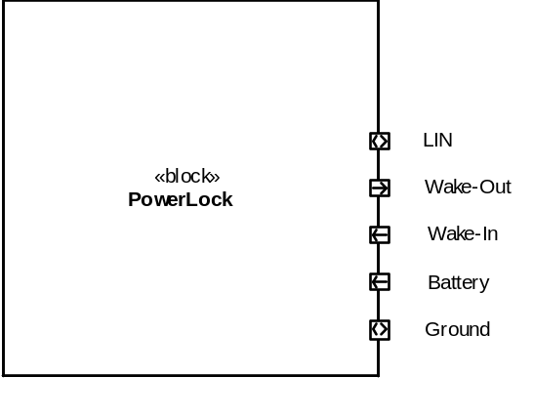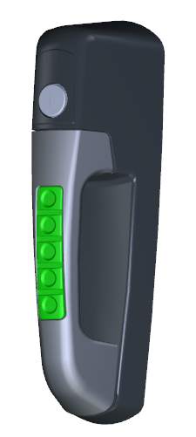

Change Notes
Indication of changes to this document.
Date | Description
17 Nov 2012 | Updated based on schematic v1.2.4
26 Sep 2012 | Updated based on schematic v1.2.3
Prior | Did not have this Change Notes section.

Reference Documents
The following documents and referenced sections are applicable to this design.
Document | Section | Description
JDQ 53.3 |  | Level 3 Device Requirements
JDQ 53.3 | 9.2.3.10 | Test Pulse for Clamped load dump
PowerLock Data Sheet | All | Electrical characteristics
SCH_11377 | v1.2.4 | Schematic

Microcontroller Signals
The following information may aid in the software development for this module and is supplemental information to the IO Allocation data in an Excel workbook.

Any pin references are referring to the pin number on the micro unless otherwise noted.

Time Base
The project does not utilize a crystal oscillator for a time-base. It uses the internal oscillator, which has some drift over time and temperature. For all timing calculations, the tolerance of this should be taken into account. Timing of pulses, backlight flashes, and key press and lockout intervals can be within a few percent of target values. With additional margin, much less than 5% error is expected. LIN packets start with a single byte that is 0x55 (or maybe it is 0xAA), and this is often used to auto-baud, so could also be used to establish timing information.

Supply Voltage (pin 20)
Power in to the micro itself is nominally 3.3v, with a 1% tolerance based on the regulator. This is the reference for the internal A/D as well.

Battery Sense An (pin 2)
Battery Sense is on Analog channel 0. This pin is also C12IN0-, which permits use of the internal comparator to shut-down the high-voltage supply in either software (by reading the analog) or hardware (by using the comparator).
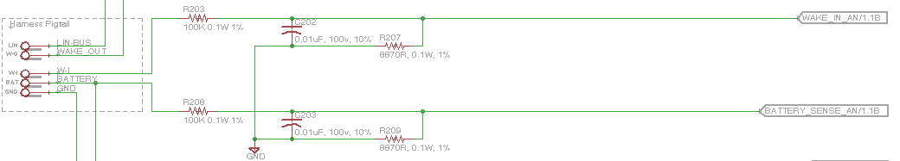

V(a/d) = Battery * 8870/(100000 + 8870)

Switcher Bypass L (pin 5)
Switcher Bypass Logic output is a logic high signal to turn on the bypass logic for the switching power supply. This signal should not be active simultaneous to the switcher.

Switcher Enable L (pin 6)
Switcher Enable Logic output (RA4) is also C1OUT, which is wired to an internal analog comparator. When high, this pin enables the switching power supply for the motor. This supply should be disabled to minimize power consumption and as a protection in over-voltage conditions. The recommendation is to use the internal Digital to Analog to set the threshold to auto-off the HV supply under high voltage conditions (e.g. Load Dump). This signal should not be activate simultaneous to the Switcher Bypass.

Switcher Power Good (pin 24)
Switcher Power Good is an active high logic input signal that indicates that the Switching supply is >= 90% of the configured voltage.
Due to the nature of the switching supply, the power good signal should be ignored for the first few milliseconds after activation of the Switcher Enable.
Further, if there is a circuit fault for causes the switching supply to come out of regulation, then the power good signal will indicate this.

Wake In An (pin 3)
Wake Input Analog it wired to a pin that is both an analog input and can be configured on a comparator input for generation of a hardware wakeup event. Wake In is an active-high signal.

Wake Output L (pin 15)
Wake Output Logic is connected to a standard port pin, where an active high enables the wake output driver to energize the Wake Out pin in the harness.

Backlight Enable L (pin 16)
Backlight Enable Logic output pin is used as an active high logic output to turn on the LEDs.

The hardware design will limit the current to the LEDs, so this pin can be set from 0 (full off) to logic 1 (full on).

It may be possible to dim the LEDs by using the SPI port this is connected to and streaming a value (e.g. 0xAA for 50%). It must be assessed if this can be done without disturbing the related pins (SDI, SCK).

H-Bridge Control 2 and 1 (pins 12, 13)
H-Bridge Control 2 and H-Bridge Control 1 are used to control the motor with the possibilities of forward, reverse, brake, or coast.

The power supply design is such that the motor is driven from either a switching 12v supply which must be enabled prior to activation of the H-Bridge, or by a low voltage bypass high side driver, after which these can be operated as simple logic output signals.

The motor has not been characterized over the temperature range; however a simple “pulse” on the order of 250 msec is likely to be sufficient.

It is recommended that the timing value is adjustable from 50 to 1000 msec via diagnostics and stored in non-volatile memory.

H-Bridge Status (pin 11)
H-Bridge Status is a port pin that can be used to monitor the H-Bridge driver for fault detection. See the specification for the H-Bridge driver chip.

Initial work on characterizing this signal has not determined if it is viable to monitor this signal for fault detection. The driven motor generates numerous false events.

Key #-# L (pins 21, 22, 23, 25, and 26)
Keypad #-# Logic input consists of 5 port pins that are pulled low when the corresponding key is pressed. These pins should be configured with internal pull-up signals.

Pins 21, 22, and 23 are INT0, INT1, and INT2, and can be used to wake up the micro from a sleep state.

Pints 25 and 26 are KBI0 and KBI1 and have IOC capability which can also wake up the micro, but require different configuration to activate.

LIN Tx, Rx (pins 17, 18)
LIN Transmit and Receive has hardware support in the UART module. Pin configuration is necessary to activate LIN on these pins.
The internal UART has an auto-baud detection mechanism designed for LIN.

LIN En (pin 14)
The LIN Enable is an active high signal to enable the LIN transceiver.

NOTE: The pin-out does not match the Lin Evaluation board that Microchip offers.

Unused Signals (pin 4, 7, 9, 10)
These signals are unused and have an external pull-down. Note that two of these signals are available for development purposes.

Operational Characteristics
The following section details the operational characteristics and control of the system, compared to the discrete signal controls documented in section 2.

Load Dump Characteristic
This device is designed to operate on either a 12 or 24 v system, and the following load dump information drawn from JDQ 53.3 is relevant to this device.

Load Dump
350 ms +/- 30 %
<= 10 ms
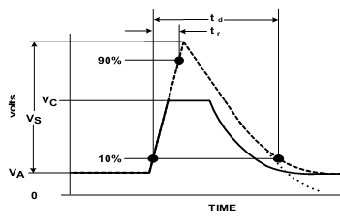
202v (28v + 174v)
56v clamped by Alternator
28v
Figure 35 from JDQ 53.3 (there appears to be an error; V_{A} should be labeled V_{B})

Table 54 from JDQ 53.3
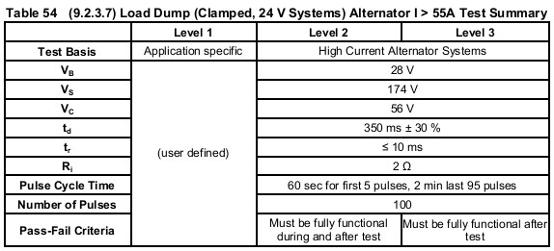

Overvoltage Power Management
Design Notes: As noted in section 2.3, the battery voltage can be measured and it can control a HV Enable pin. In order to manage the overall power dissipation of the system, the following subordinate requirements shall be supported.

Motor Supply Voltage Control
There are two power supplies that can provide power to the motor. Due to the characteristics of the motor and mechanical circuitry, as well as the characteristics of the switching supply at low voltage, the switching supply alone is insufficient to meet the low voltage operation.

Switching Supply Mode
The switching supply is designed to operate over the higher voltage range of the product. When the battery voltage is measured at 16 and higher, the unit should be configured to Switching Supply mode, and demands to control the motor would be satisfied by activating the switching supply.

Low Voltage Bypass Mode
The low voltage bypass is designed to operate in low voltage and 12v systems. When the battery voltage is measured at 15v and lower, the unit should be configured in Low Voltage Bypass mode, and demands to control the motor would be satisfied by activating the bypass supply.

Common Requirements
If the system voltage is between 15v and 16v, operating mode should be based on the prior sensed condition, to prevent “jumping” between modes unnecessarily.

At a system voltage of Battery JUMP or higher, both the HV Enable and the Switcher Bypass shall be set low to disable the supply to the H-Bridge and motor. This may be done by hardware configuration of the comparator for the switcher, via software. Further, the drive signals for the following subsystems shall be disabled or turned off.
- H-Bridge to the Motor.

12v and Logic Supply Power Control
Design Notes: The 12v low current regulator and the 3.3v logic supply regulator are linear regulators, and if power consumption is unmanaged they could reach their power dissipation limits. Active management for this consists of controlling the average current drain for the PIC and peripheral components (e.g. shutting down backlight LEDs, wake out, diagnostic LEDs, and entering sleep mode).

As the system is not required to operate in over-voltage conditions, it is permissible to control a number of behaviors including reducing or stopping the clock (as long as recovery is automatic when the voltage drops).

Motor Control
Design notes: The initial switching supply design was intended to provide sufficient power to the motor under “normal” conditions and insufficient power under “stall” conditions. In this way, the stall current would pull down the supply, the “power good” signal would drop, and this would be the feedback path to indicate “end of travel”. The software would then be self-timed to the hardware to determine when to stop the motor drive pulse. With the switching supply circuit and the available motor, this concept has not proven to be valid.

As a result, the recommendation is that the motor drive pulse be configured via software as noted in an earlier section.

Further, while the components operate at very low power, it may be appropriate to place a limit on the number of lock/unlock cycles per minute, with an initial recommendation of 5 (a somewhat arbitrary number). This limit should also be stored in EEROM and accessible.

