Project: Customizable Telematics Platform

The general purpose of the finished product is to be a customizable telematics and datalogging platform based on the MBED LPC1768 microcontroller, assembled in a rugged enclosure. The device will have several standard hard-wired I/O, as well as some configurable I/O and spare circuits. The usage of this device is primarily to assist with troubleshooting intermittent issues on fire apparatus in near real-time, as well as provide feedback on vehicle usage.

Scope of work
The scope of work includes all electrical circuit and PCB design, including the proper selection of components to meet the specifications below. The contractor is not required to provide any components.
- The design is “best-effort” since the project scope is to provide the ability to build, not a built and proven unit. The intent is to meet the requirements for:
  - Normal voltage operation: 9V to 16V operating,
  - Non-Operating:
    - 26V jump-start,
    - Load Dump,
    - Reverse Voltage Protection
  - Temperature: -40 to +85C for all components excluding modules: LPC1768, XBEE
- Out of scope design:
  - EMI/EMC: The design will follow normal practices for proper EMI/EMC. The modules may dominate the overall EMI/EMC behavior.
    - The PCB may be 2-layer, for a lower cost, or 4-layer for improved EMI/EMC (where the inner layers are power and ground planes, not signal layers)
  - Humidity: This is primarily a function of board level coating, and enclosure sealing
  - Vibration: Vibration will be considered for component placement. For removable components, a means will be provided to strap them with tie-downs
- Out of scope verification, which requires laboratory equipment:
  - EMI/EMC
  - Load Dump
  - Temp/Humidity/Vibration

Deliverables
The deliverables for this project include the documentation necessary to translate the design into a product.
Documentation deliverables include:
- Component Data sheets,
- Schematics,
- PCB board layout files,
- Bill of materials,
- Special instructions as may be needed for assembly,
- 10 bare PCBs boards will be provided by the contractor, unpopulated with components,
- The contractor may be provided with 1 to 2 units for HW checkout / modifications as needed.

Power Management
The device is primarily powered by a vehicle battery. All power management is delegated to the software, and the ability to reduce power consumption of on-micro and external circuits. One of the general-purpose IO may be used to monitor a switched power input.

There is no requirement for additional internal hardware power control circuitry.

External Signal Requirements
The completed device will contain the following functions/features available at the external connector. Some functions may be alternately available as may be constrained by the required components (LPC1768, XBEE).

Power
2 Pins, functionally as follows:
- Battery Input
- Ground

CAN
4 Pins, functionally as follows:
(2) CAN Channels, each simultaneously accessible through the device connector, no internal terminating resistors.

Serial
The design shall support either a J1708/J1587 interface or an RS-232 interface, with internal jumpers to configure which is active. This is a limitation of the LPC1768 without implementing the serial interface purely in software. Each shall have dedicated connector pins.

J1708/J1587
2 Pins, functionally as follows:
(1) J1708/J1587 Channel, accessible through the device connector

RS232
3 Pins, functionally as follows:
(1) RS232 Receive
(1) RS232 Transmit
(1) RS232 Ground

General Purpose IO
4 Pins, functionally as follows:

(4) General purpose I/O. Each pin shall be independently configurable using jumpers and software with the following capabilities:
Grounding Input
12 volt input
500 mA Sourcing or Sinking output (design can accept either and does not require both source and sink)

For the grounding and 12v input, will it be switch contacts, or connection to some other circuit. If switch contacts, then we should specify gold contacts (and very low current), or non-precious metal contacts, and “contact cleaning current” requirement to reduce contact oxidation and failure.

Analog Sensor Support
5 Pins, functionally as follows:

(3) 5 volt analog inputs, overvoltage protection is optional.
Independent 5 volt power and ground accessible externally for analog sensors.

Example use-case: Pressure sensor: https://www.digikey.com/product-detail/en/honeywell-sensing-and-productivity-solutions/MLH300PSB01A/480-2598-ND/1248933

PCB Level Signal Requirements

Battery Input voltage measurement
Analog sensing of battery input signal with a measurement range up to a minimum of 16V with at least 0.1V resolution.
NOTE: The LPC1768 A/D is quite noisy. This circuit should have heavy RC-filtering and may require additional software filtering.

Micro SD - Internal
(1) Micro SD card, not accessible externally.

Module – LPC1768
(1) socket for MBED LPC1768 microcontroller

The socket will be a double row of pins, for ease of testing and possible installation of a daughterboard if the PCB is not mounted within the enclosure. The socket for the MBED LPC1768 should be located in a way that the USB connector is accessible when the PCB is removed from the enclosure without having to remove the antenna connector.

Additional holes in the PCB should be located so that a tie-strap could be used to prevent vibration from dislodging the module.

LPC1768 Pinout Assignments
Pin | Function | 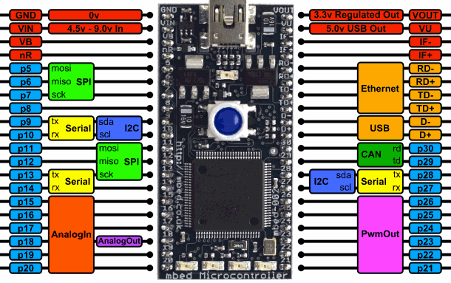 | Function | Pin
1 | Ground |  |  | 40
2 | Vin |  |  | 39
3 | VBat(RTC) |  |  | 38
4 | /Reset |  |  | 37
5 | MicroSD |  |  | 36
6 | MicroSD |  |  | 35
7 | MicroSD |  |  | 34
8 | MicroSD(Select) |  |  | 33
9 | CAN 1 |  |  | 32
10 | CAN 1 |  |  | 31
11 | LED 1 |  | CAN 2 | 30
12 | LED 2 |  | CAN 2 | 29
13 | RS232 |  | XBEE | 28
14 | RS232 |  | XBEE | 27
15 | UNUSED |  | XBEE | 26
16 | Ain 5 |  | XBEE | 25
17 | Ain 4 |  | GPIO4 | 24
18 | Ain 3 |  | GPIO3 | 23
19 | Ain 2 |  | GPIO2 | 22
20 | Ain 1 (Batt) |  | GPIO1 | 21

NOTE: While not a requirement of the initial design, pins 11 – 14 may have a future use for an LCD display and should not be allocated to essential functions.

Module – XBEE
(1) socket for XBEE Wi-Fi or XBEE Cellular Module (datasheets attached, samples available)

The Wi-Fi and cellular modems are 20 pin devices with compatible pinouts. The socket should be mounted toward the top of the PCB.

Additional holes in the PCB should be located so that a tie-strap could be used to prevent vibration from dislodging the module.

The pins used in this application are as follows:

1 | VCC/Power |  | 11
2 | Data Out (connect to mbed serial in) |  | 12
3 | Data In (connect to mbed serial out) |  | 13
4 | DIO12 / TCP Established (mbed digital I/O) |  | 14
5 |  |  | 15 | DIO5 / Associate (mbed digital I/O)
6 |  |  | 16
7 |  |  | 17
8 |  |  | 18
9 |  |  | 19
10 | Ground |  | 20

Unused pins will still be accessible with a plated hole adjacent to the socket. A power supply shall be included in the design with sufficient power to run the modem, without causing undesired voltage drops at other parts of the device.

The part numbers used for the modems are as follows:
Modem | Digi Part number | Digikey Part Number
Wi-Fi | XB2B-WFUT-001 | 602-1378-ND
Cellular | XB3-C-A1-UT-001 | 602-2211-ND

Both modems can be supplied for reference.

LED Indicators
Preferred LED indicator location shall be specified in the overall PCB layout.
(1) LED indicator for Power
(2) LED indicators controlled by microcontroller

General Construction
For reference, the terms Front, Back, Top, Bottom, Left, and Right will be used, and refer to the following:
Bottom – the edge of the board closest to the enclosure connectors
Top – the edge of the board opposite of the enclosure connectors
Front – the surface of the PCB that the majority of the components mount to
Back – the “solder side” of the board
Left / Right – as viewed from the front of the board, connectors toward the bottom.

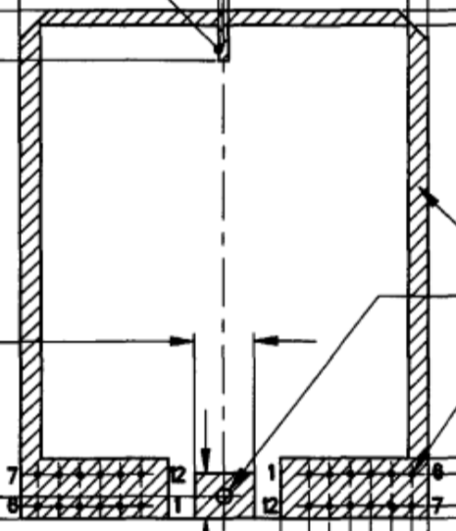

PCB General Layout (connector at the bottom).

Any unused pins for the modem socket, MBED, or enclosure connectors should be connected to plated though holes in the PCB for future use.
Any unused space on the PCB should be populated with pads plated through holes on a 100 mil grid for future use.
All components should be through-hole or SMT larger components that may be installed by hand.
Three or Four holes that will fit a #4 machine screw shall be provided on the PCB for applications where the PCB is mounted to a surface rather than within the Deutsch enclosure.
The PCB should utilize double sided construction, if possible, to allow modification of traces for application specific situations. If 4-layer design is implemented, the inner layers should be only power and ground planes, and not signal layers.
The PCB should be supplied with standard green solder mask and silkscreen.

Enclosure
The enclosure will be made of the following two Deutsch components:
Description | Deutsch P/N | Digikey P/N
Enclosure | EEC-325X4A-E016 | 1734-1063-ND
Connector Base | DTM13-12PA-12PB-R008 | 1734-1131-ND

A sample of both components can be supplied for reference.

External Connections
Below is a table showing the preferred pinout for external connections. It would be preferred to maintain at least the gray connector pinout in order to match existing modules.

Grey Connector |  |  | Black Connector
1 | Spare |  | 1 | Analog Ground
2 | Spare |  | 2 | 5 volt Analog Supply
3 | Spare |  | 3 | Digital Input / Output 1
4 | RS232GND |  | 4 | Digital Input / Output 2
5 | RS232TX |  | 5 | Digital Input / Output 3
6 | RS232RX |  | 6 | Digital Input / Output 4
7 | CAN2 Low |  | 7 | J1708A
8 | CAN2 High |  | 8 | J1708B
9 | CAN1 Low |  | 9 | Analog in 1
10 | CAN1 High |  | 10 | Analog In 2
11 | Module Ground |  | 11 | Analog in 3
12 | Module Battery |  | 12 | Analog In 4

Would prefer to move the 5V Analog Supply and Ground to pins adjacent to the Analog In 1 – 4.

The antenna port for the Wifi or Cellular module will exit the enclosure through a drilled hole, opposite of the end that the connectors are on. The antenna will have a 6” lead for attaching to the u.fl connector on the modem.

