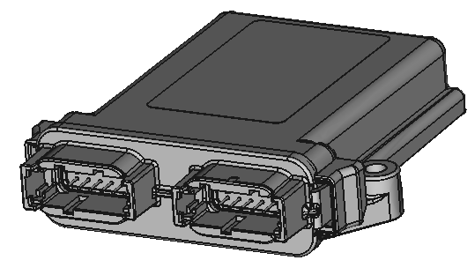

Document: Hughes Telematics Platform Specification, v0.1
Company: Hughes Fire Equipment, Inc.
910 Shelley Street
Springfield, OR 97477
Phone: 541.747.0072

The general purpose of the finished product is to be a customizable telematics and datalogging platform based on the MBED LPC1768 microcontroller, assembled in a rugged enclosure. The device will have several standard hard-wired I/O, as well as some configurable I/O and spare circuits. The usage of this device is primarily to assist with troubleshooting intermittent issues on fire apparatus in near real-time, as well as provide feedback on vehicle usage.

Table of Contents
1 Scope of work 3
1.1 Best Effort 3
1.2 Out of Scope – Design 3
1.3 Out of Scope – Verification 3
2 Deliverables 3
3 Power Management 4
4 External Signal Requirements 4
4.1 Power 4
4.2 CAN 4
4.3 Serial 4
4.3.1 J1708/J1587 4
4.3.2 RS232 5
4.4 General Purpose IO 5
4.5 Analog Sensor Support 5
5 PCB Level Signal Requirements 6
5.1 Battery Input voltage measurement 6
5.2 Micro SD - Internal 6
5.3 Module – LPC1768 6
5.3.1 LPC1768 Pinout Assignments 6
5.4 Module – XBEE 7
5.5 LED Indicators 7
6 General Construction 8
7 Enclosure 9
8 External Connections 10
9 Document History 11
10 Specification Review and Approval 11
10.1 Defer to Informal Email Approval Process: 11
10.2 Manual Signature Process: 11
10.3 Electronic Signature Process: 12

Scope of work
The scope of work includes all electrical circuit and PCB design, including the proper selection of components to meet the specifications below. The contractor is not required to provide any components.

Best Effort
The design is “best-effort” since the project scope is to provide the ability to build, not a built and proven unit. The intent is to meet the requirements for:
- Normal voltage operation: 9V to 16V operating,
- Non-Operating:
  - 26V jump-start,
  - Load Dump,
  - Reverse Voltage Protection
- Temperature: -40 to +85C for all components excluding modules: LPC1768, XBEE

Out of Scope – Design
Elements of the design are out of scope as they require advanced laboratory equipment. Examples include:
- EMI/EMC: The design will follow normal practices for proper EMI/EMC. The modules may dominate the overall EMI/EMC behavior.
  - The PCB may be 2-layer, for a lower cost, or 4-layer for improved EMI/EMC (where the inner layers are power and ground planes, not signal layers)
- Humidity: This is primarily a function of board level coating, and enclosure sealing
- Vibration: Vibration will be considered for component placement. For removable components, a means will be provided to strap them with tie-downs

Out of Scope – Verification
Elements of verification are out of scope as they require advanced laboratory equipment. Examples include:
- EMI/EMC
- Load Dump
- Temp/Humidity/Vibration

Deliverables
The deliverables for this project include the documentation necessary to translate the design into a product.
Documentation deliverables include:
- Component Data sheets,
- Schematics,
- PCB board layout files,
- Bill of materials,
- Special instructions as may be needed for assembly,
- 10 bare PCBs boards will be provided by the contractor, unpopulated with components,
- The contractor may be provided with 1 to 2 units, including a mating connector and pins, for the purpose of HW checkout or modifications.

Power Management
The device is primarily powered by a vehicle battery. All power management is delegated to the software, and the ability to reduce power consumption of on-micro and external circuits. One of the general-purpose IO may be used to monitor a switched power input.
NOTE: During design, additional internal hardware power control circuitry will be investigated with a goal to implement a power-management method to significantly reduce power, or to fully turn-off the module until a switched power input is activated to the 12V supply. It is acceptable if this allocates one of the GPIO pins as the switched power input.

External Signal Requirements
The completed device will contain the following functions/features available at the external connector. Some functions may be alternately available as may be constrained by the required components (LPC1768, XBEE).

Power
Power is provided via 2 Pins, functionally as follows.
Pin | Signal | Notes
1 | Battery Input | Operating: 9 to 16V, nominally 13.2V, reverse voltage protected.  Non-operating: Jump-start and load-dump tolerant.
2 | Ground | Vehicle Ground

CAN
CAN Interface is provided via 4 Pins, functionally as follows.
Pin | Signal | Notes
1 | CAN1-H | No internal termination
2 | CAN1-L | No internal termination
3 | CAN2-H | No internal termination
4 | CAN2-L | No internal termination
Each CAN interface shall have a PCB level jumper to restrict the CAN channel to Listen-Only mode. When not restricted, the node can send CAN messages to the network.

Serial
The design shall support dedicated connector pins (2) for a J1708/J1587 interface, and dedicated connector pins (3) for an RS-232 interface.
As the LPC1768 has insufficient pins to support all communications interfaces, internal jumpers select which of the Serial interfaces is actively usable at the connector.

J1708/J1587
The J1708/J1587 interface is provided via 2 Pins, functionally as follows:
Pin | Signal | Notes
1 | J1708+
2 | J1708-

RS232
The RS232 interface is provided via 3 Pins, functionally as follows:
Pin | Signal | Notes
1 | Receive
2 | Transmit
3 | Ground

General Purpose IO
The 4 General Purpose IO is each independently available via 4 Pins. Each independent channel can be configured in one of several modes.
Pin | Signal | Notes
1 | GPIO1
2 | GPIO2
3 | GPIO3
4 | GPIO4
Hardware Configuration options for each GPIO are as follows:
Option | Signal | Notes
1 | Grounding Input | Switch closure to ground, Internal protection and pullup.
2 | 12V Input | Switch closure to 12V, Internal protection and pulldown.
3 | High Side Driver | 12V source, minimum 500 mA drive. Overload protection.
Note: An alternative of Low-Side drive is permissible and may be deferred to the electrical design phase.
Note: For the Switch sense configuration, no special requirements are defined for minimum or maximum contact current or contact cleaning current.

Analog Sensor Support
There shall be analog sensor support via 5 Pins, 3 for analog input signals and 2 for sensor power, functionally as follows:
Pin | Signal | Notes
1 | 5V Sensor Power | Independent of the internal processor power supply
2 | Sensor Ground
3 | Ain1 | Configuration for 0 to 5V, internally scaled to full scale on the A/D
4 | Ain2
5 | Ain3
Note: There shall be a PCB configurable internal high impedance pulldown on each input to facilitate open circuit detection.
Example Use-case:
Modem | Manufacturer Part number | DigiKey Order Number
Honeywell Pressure Sensor | MLH300PSB01A | 480-2598-ND

PCB Level Signal Requirements

Battery Input voltage measurement
Analog sensing of battery input signal with a measurement range up to a minimum of 16V with at least 0.1V resolution.
NOTE: The LPC1768 A/D is quite noisy. This circuit shall have heavy RC-filtering and may require additional software filtering.

Micro SD - Internal
(1) Micro SD card, not accessible externally. A connector should be chosen to minimize the possibility of vibration dislodging the micro SD card.

Module – LPC1768
(1) socket for MBED LPC1768 microcontroller
The socket will be a double row of pins, for ease of testing and possible installation of a daughterboard if the PCB is not mounted within the enclosure. The socket for the MBED LPC1768 should be located in a way that the USB connector is accessible when the PCB is removed from the enclosure without having to remove the antenna connector.
Additional holes in the PCB should be located so that a tie-strap could be used to prevent vibration from dislodging the module.

LPC1768 Pinout Assignments
Pin | Function | 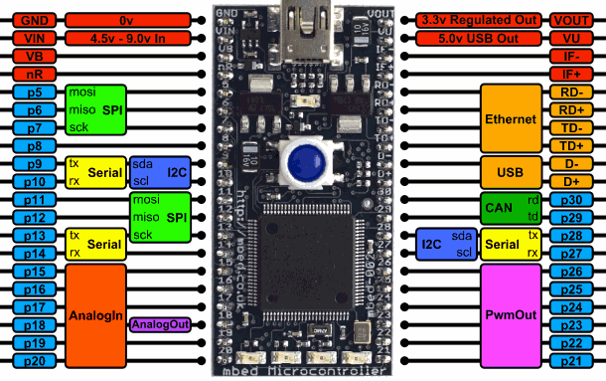 | Function | Pin
1 | Ground |  |  | 40
2 | Vin |  |  | 39
3 | VBat(RTC) |  |  | 38
4 | /Reset |  |  | 37
5 | MicroSD |  |  | 36
6 | MicroSD |  |  | 35
7 | MicroSD |  |  | 34
8 | MicroSD |  |  | 33
9 | CAN 1 |  |  | 32
10 | CAN 1 |  |  | 31
11 | LED 1 |  | CAN 2 | 30
12 | LED 2 |  | CAN 2 | 29
13 | RS232 |  | XBEE | 28
14 | RS232 |  | XBEE | 27
15 | UNUSED |  | XBEE | 26
16 | Ain 5 |  | XBEE | 25
17 | Ain 4 |  | GPIO4 | 24
18 | Ain 3 |  | GPIO3 | 23
19 | Ain 2 |  | GPIO2 | 22
20 | Ain 1 (Batt) |  | GPIO1 | 21
NOTE: While not a requirement of the initial design, pins 11 – 14 may have a future use for an LCD display and should not be allocated to essential functions.
NOTE: Unused pins.

Module – XBEE
(1) socket for XBEE Wi-Fi or XBEE Cellular Module.

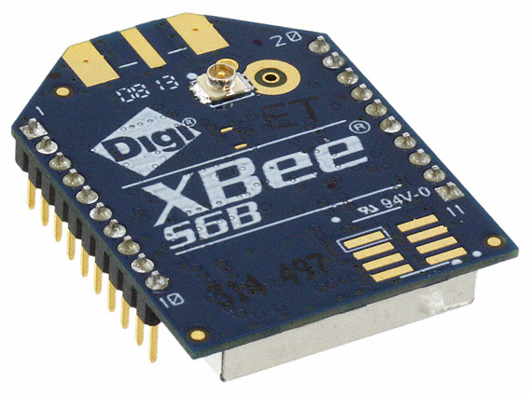 | 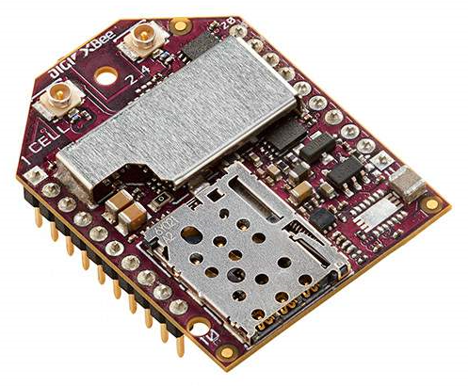
The Wi-Fi and cellular modems are 20 pin devices with compatible pinouts. The socket should be mounted toward the top of the PCB to facilitate antenna routing.
Additional holes in the PCB should be located so that a tie-strap could be used to prevent vibration from dislodging the module.
The XBEE pins used in this application are as follows:
Pin | Signal |  | Pin | Signal
1 | VCC/Power |  | 11
2 | Data Out (connect to mbed serial in) |  | 12
3 | Data In (connect to mbed serial out) |  | 13
4 | DIO12 / TCP Established (mbed digital I/O) |  | 14
5 |  |  | 15 | DIO5 / Associate (mbed digital I/O)
6 |  |  | 16
7 |  |  | 17
8 |  |  | 18
9 |  |  | 19
10 | Ground |  | 20
Unused pins will still be accessible with a plated hole adjacent to the socket. A power supply shall be included in the design with sufficient power to run the modem, without causing undesired voltage drops at other parts of the device.
The part numbers used for the modems are as follows:
Modem | Manufacturer Part number | DigiKey Order Number
Wi-Fi | XB2B-WFUT-001 | 602-1378-ND
Cellular | XB3-C-A1-UT-001 | 602-2211-ND

LED Indicators
Preferred LED indicator location shall be specified in the overall PCB layout.
(1) LED indicator for Power
(2) LED indicators controlled by microcontroller
Consider: The LPC1768 has 5 LEDs, one which is effectively an indication of power (and serial traffic to the USB port), and 4 individually controllable LEDs. If those are used instead of these dedicated LEDs, the additional IO may be useful. If dedicated LEDs are desired, is any preference for location on the PCB and color for each?

General Construction
For reference, the terms Front, Back, Top, Bottom, Left, and Right will be used, and refer to the following:
- Bottom – the edge of the board closest to the enclosure connectors
- Top – the edge of the board opposite of the enclosure connectors
- Front – the surface of the PCB that the majority of the components mount to
- Back – the “solder side” of the board
- Left / Right – as viewed from the front of the board, connectors toward the bottom.

PCB General Layout (connector at the bottom):
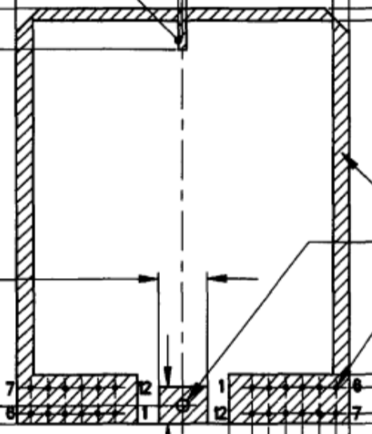
Any unused pins for the modem socket, MBED, or enclosure connectors should be connected to plated though holes in the PCB for future use.
Any unused space on the PCB should be populated with pads and plated through holes on a 100 mil grid for future use.
All components should be through-hole or larger SMT components that may be readily installed by hand.
Three or Four holes that will fit a #4 machine screw shall be provided on the PCB for applications where the PCB is mounted to a surface rather than within the Deutsch enclosure.
The PCB should utilize double sided construction, if possible, to allow modification of traces for application specific situations. If 4-layer design is implemented, the inner layers should be only power and ground planes, and not signal layers.
The PCB should be supplied with standard green solder mask and silkscreen.

Enclosure
The enclosure will be made of the following two Deutsch components:
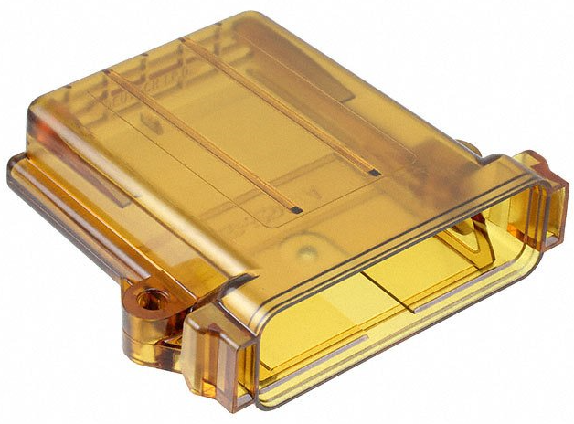 | 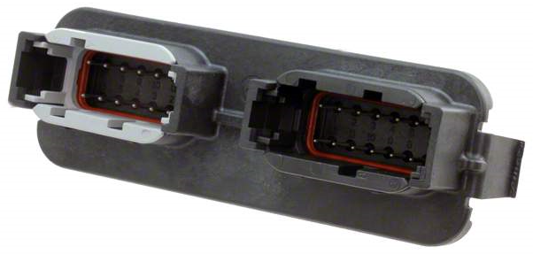

Description | Manufacturer Part Number | DigiKey Order Number
Enclosure | EEC-325X4A-E016 | 1734-1063-ND
Connector Base | DTM13-12PA-12PB-R008 | 1734-1131-ND
The antenna port for the Wifi or Cellular module will exit the enclosure through a drilled hole, opposite of the end that the connectors are on. The antenna will have a 6” lead for attaching to the u.fl connector on the modem.

External Connections
Below is a table showing the preferred pinout for external connections. It would be preferred to maintain at least the gray connector pinout in order to match existing modules.
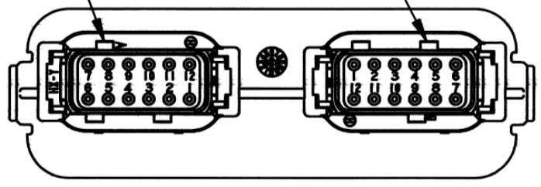
Module Connector Pin Numbering – Gray on Left, Black on Right
Grey Pin | Signal |  | Black Pin | Signal
1 | Optional Switched Power |  | 1 | Analog Ground
2 | Spare |  | 2 | 5-volt Analog Supply
3 | Spare |  | 3 | Digital Input / Output 1
4 | RS232GND |  | 4 | Digital Input / Output 2
5 | RS232TX |  | 5 | Digital Input / Output 3
6 | RS232RX |  | 6 | Digital Input / Output 4
7 | CAN2 Low |  | 7 | J1708A
8 | CAN2 High |  | 8 | J1708B
9 | CAN1 Low |  | 9 | Analog in 1
10 | CAN1 High |  | 10 | Analog In 2
11 | Module Ground |  | 11 | Analog in 3
12 | Module Battery |  | 12 | Analog In 4

Document History
Changes in this specification that can cause physical, electrical, or software functionality changes shall be documented here, as a revision to this document.
Version | Date | Change Notes
0.1 | 4 Apr 2019 | Original draft for interactive review
1.0 |  | First approved version

Specification Review and Approval
This section contains the review sign-off/approval for this project to continue through the design work. Three options for approval are available, only 1 of which is required.
Doc Version | Date Approved | Reviewer, Company

Defer to Informal Email Approval Process:
To defer to a less formal email approval process, this single page may be used.
- Print, Sign and Date here, Scan
- Add this signed page to the configuration management repository.
- Reviews may then be approved with an email referencing the specific document version.

Manual Signature Process:
Signed approval of each document version should follow this process.
- Print at a minimum the pages containing the Document History and Specification Review and Approval pages. Alternately, the entire document may be printed.
- Fill in and sign the entry in the Specification Review and Approval section.
- Scan to an electronic format.
- Add to configuration management as a separate document with a filename-based date-stamp suffix “-YYYYMMDD.ext”.

Electronic Signature Process:
- Check-out the current version from revision control.
- Review for approval.
- Fill in a row in the Specification Review and Approval section.
- Committing the change back into configuration management using your credentials.

