Version 1.0 Errata and Corrections, and Change Requests
Table of Contents
Mbed – single row socket 1
Location of mbed 1
RTC Battery 1
L1/L2 1
3.3V supply at 3.98V 3
Shutdown Circuit 5
RS232 9

Mbed – single row socket
To improve space-claim in the module, reduce the mbed to a single-row.
Fix: V1.1 – changed to single row.

Location of mbed
It is snug against the inside ramp of the enclosure. Moving it 0.1” to the right will relieve that interference and permit the tie-strap to be used.
Fix: V1.1 – moved mbed 0.1” toward the center.

RTC Battery
Add a battery for the RTC. Ideally, it should reliably trap the battery, either w/in the holder, or by location against the housing so the battery cannot vibrate loose.
“As far as the battery discussion below, I think due to space, we are going to have to go with the BS-1225-PC-ND below. Or, if space is an issue on the PCB, I am totally fine with a 2 pin header that I can plug in to and remote mount the battery “
Fix: V1.1 – Added the BS-1225-PC-ND battery holder.

L1/L2
L1 | L2
From the TI Webench Power Designer: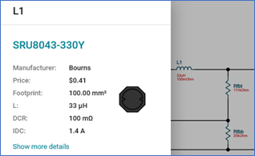 | 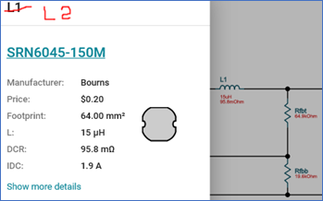
Eagle schematic:  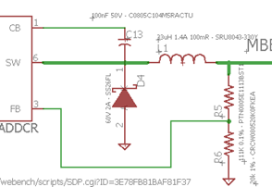 | Eagle Schematic  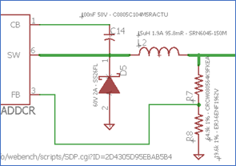
Eagle Library  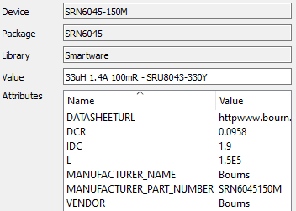 | Eagle Library  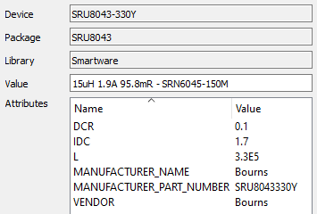
Each part has the package(footprint) of the other part.
I ran some other simulations with the parts swapped. In general, they are both very close in requirements, and also in performance. The 15 uH part will run a bit hotter on the 5V circuit, but this would be most noticeable at high ambient temp. Also, there are some very minor differences in regulation, and response to step-change load current, but so minor that we should not notice.
In Summary, it should not be cause for throwing away this unit.

Sample simulation
5v w/original 33uH | 5v w/modified 15 uH
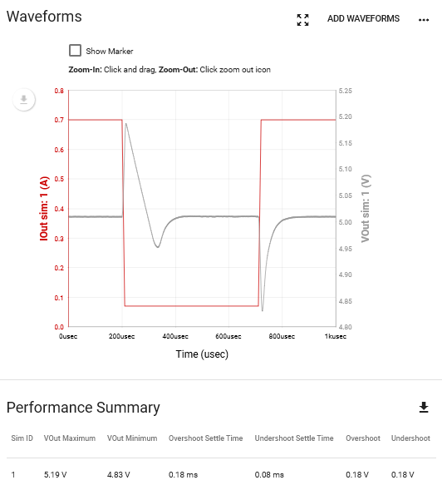 | 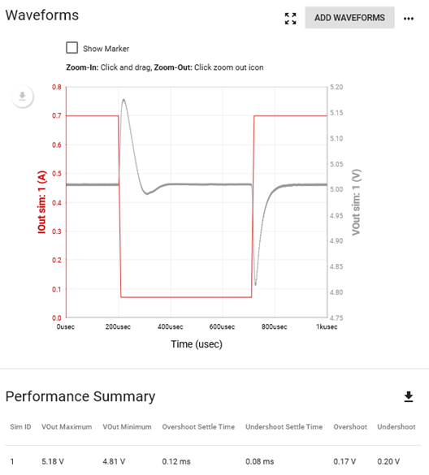

Consider ordering the alternate part in the alternate size.

3.3V supply at 3.98V
3.3V is not operating properly. I can’t find any assembly errors. Connections all check out, and no measured evidence of solder bridges found. Any chance V_PROT could be supplying power through R13, then through D8, on to the 3V3 circuit? (schematic 5.1A) Noticed that with the XBEE modem disconnected, “off” state voltage on 3V3 line was 3.9 volts, and with modem installed, voltage dropped down to 1.3 ish (varied, probably because modem was trying to power up). Seemed like voltage drop across a resistor. I can temporarily remove R13 tomorrow to test that theory…
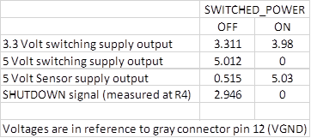
As you see in the schematics, the two circuits are basically identical – varying only in value.
My first assumption is that there is either an unsoldered joint, or there may be a solder bridge between two pins. If you put the L1 where L2 belongs and L2 where L1 belongs (so they fit well), then it should be easy to inspect around them for shorts.
I’m also suspicious that maybe U4 pin 2 or pin 3 is not connected.
With two virtually identical circuits, there’s a few easy things to do –
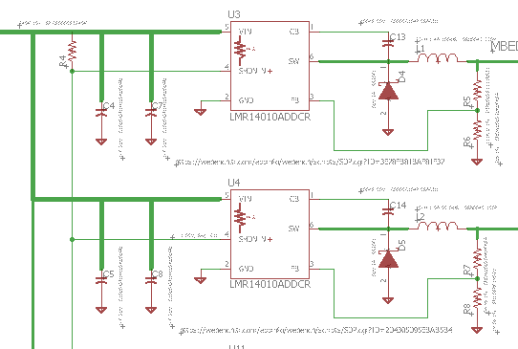
Starting completed unpowered, and with a few moments time for the caps to discharge, measure the resistance from each pin of U3 to ground, and then separately you might measure the resistance between the pins.
Repeat that for U4.
And I’m sure you know to keep the red/black leads oriented the same way for the measurements on each chip, so we don’t get misled by the direction of current flow.
In case one of the pins on U4 is not fully soldered to the pad, you will want to touch the pin with your meter lead ever so gently, or it may make contact while you make the measurement.
Fix: Isolate alternate paths to 3.3v clamp with a Zener.

Shutdown Circuit
In re-reading the datasheet, the “shutdown” input logic for the switching supplies is the reverse of what I interpreted. It is painfully, and obviously, clear now –

For the 5V Sensor supply, it is the reverse of the switching supply – so the logic is the way I [mis]-interpreted for all the parts. Shutdown = 0V, On = Input high.
In looking at the schematic, we need to isolate the SHDN_N pins on U3 and U4 from the rest of the shutdown circuit. It turns out this is possible with only a single PCB cut.

Cut the trace at the yellow “X”.
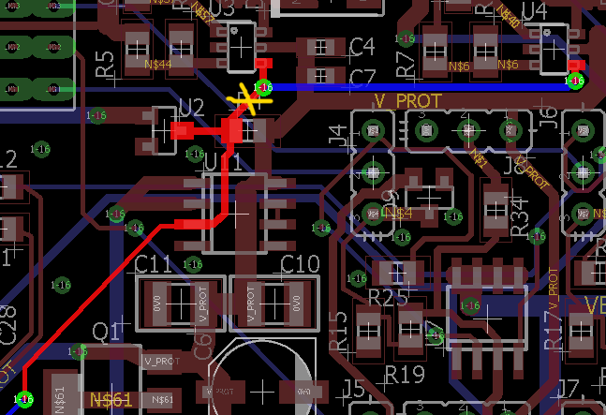
Now, the shutdown state for these is with an input voltage < ~ 1.25V.
That exists in two locations –
- The 5V Sensor Output. But, if we connect it to the 5V sensor, and there is an external fault that grounds the 5V sensor supply, you cannot turn the module on to phone home about the fault.
- The Gate on U1. Here the concern is getting the right voltage – which will be affected by the high-impedance pull-ups in U3 and U4.
Compared to the impedance of R1 and R2, these are probably 10 to 50 x higher, so this should work.

I think you can jumper from the U3,U4 SHDN_N to the KEY_SENSE signal.
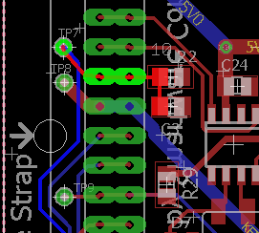
If you have a wire small enough, this might be easiest on the bottom side connecting MBED Pin 11 (or TP7) and the via near Pin 6 of U3.
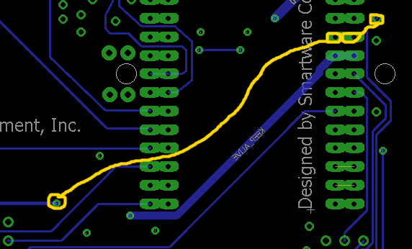
If you don’t have any tiny wire, then a wire on the top-side might be easier.
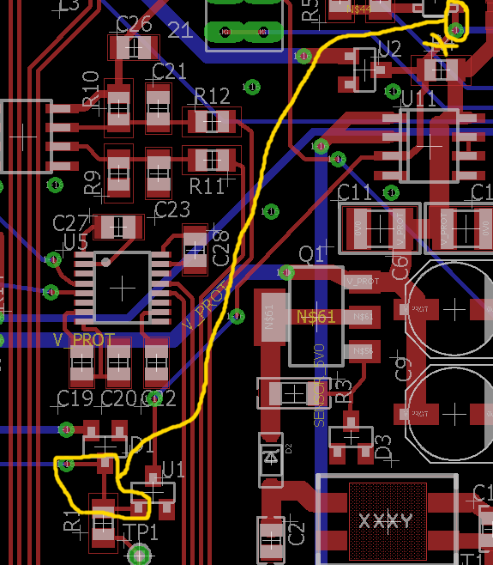
Fix: Revise power mgmt. circuit for correct polarity of control.

RS232
Vcc is not connected and should be part of 3V3.
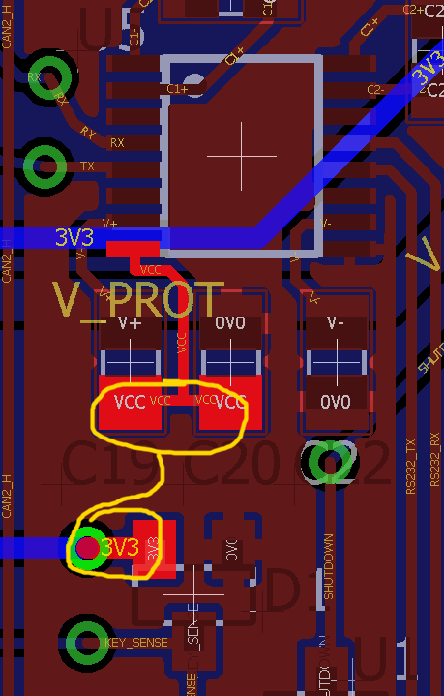
Fix: V1.1 rewired to 5V0 which is layout-wise more convenient.

