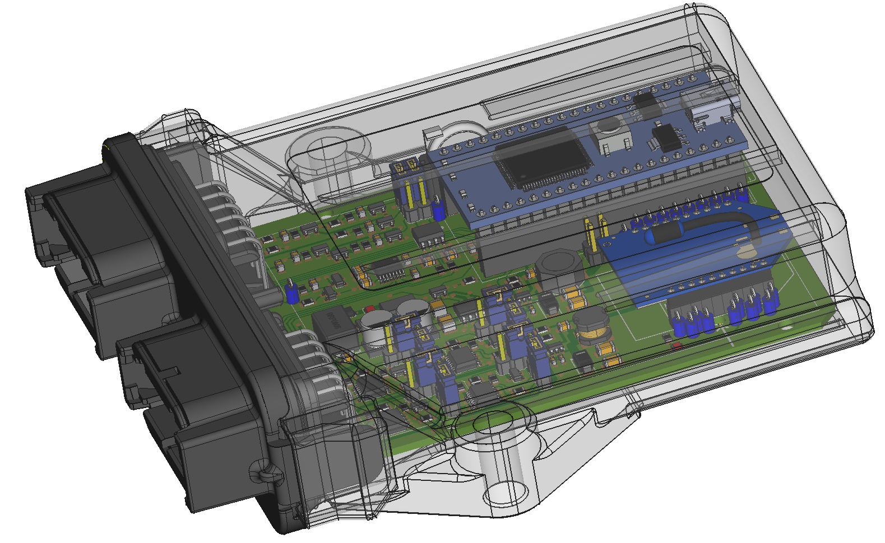

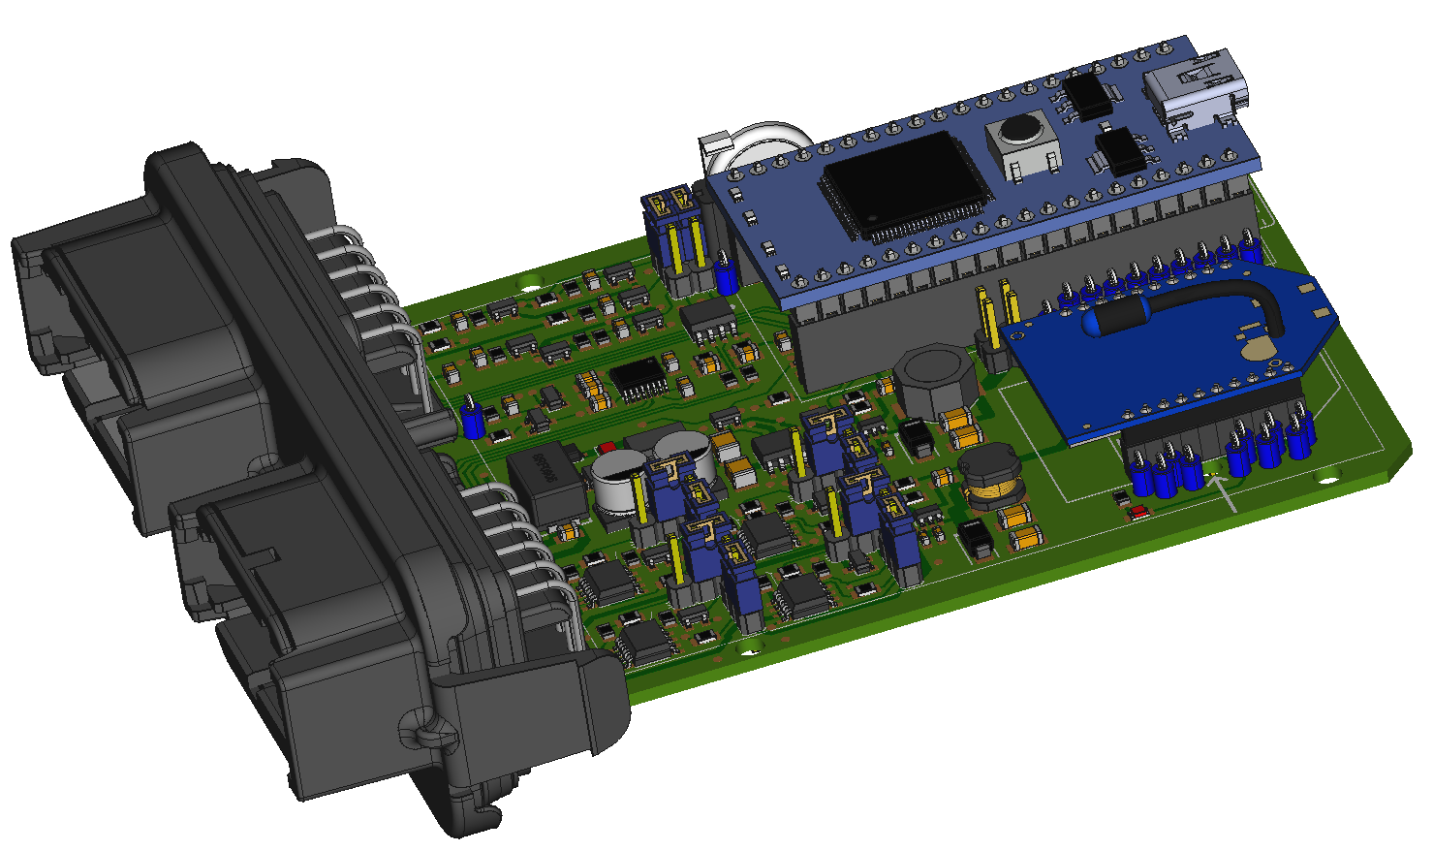

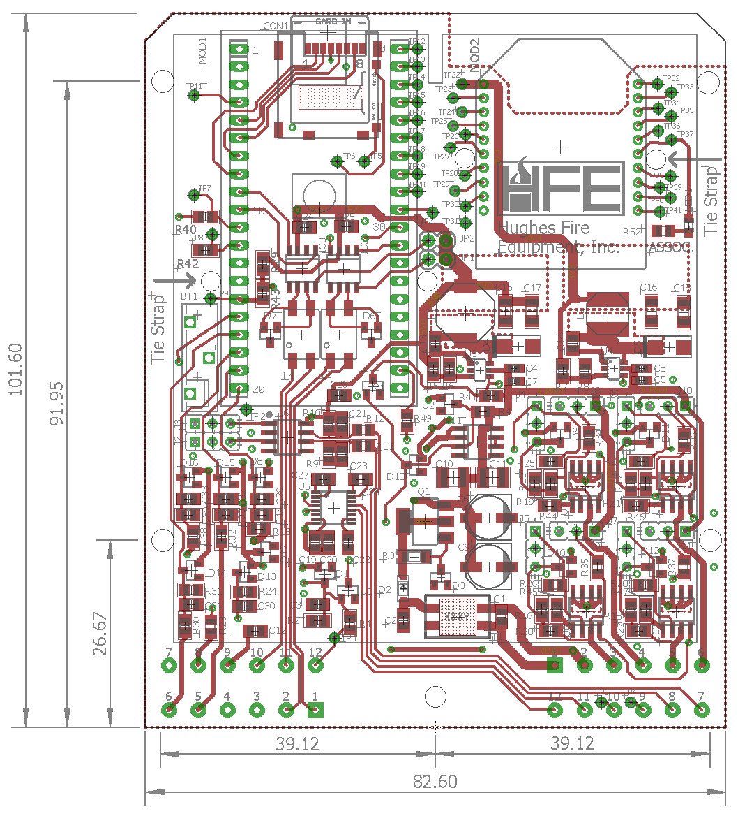 | 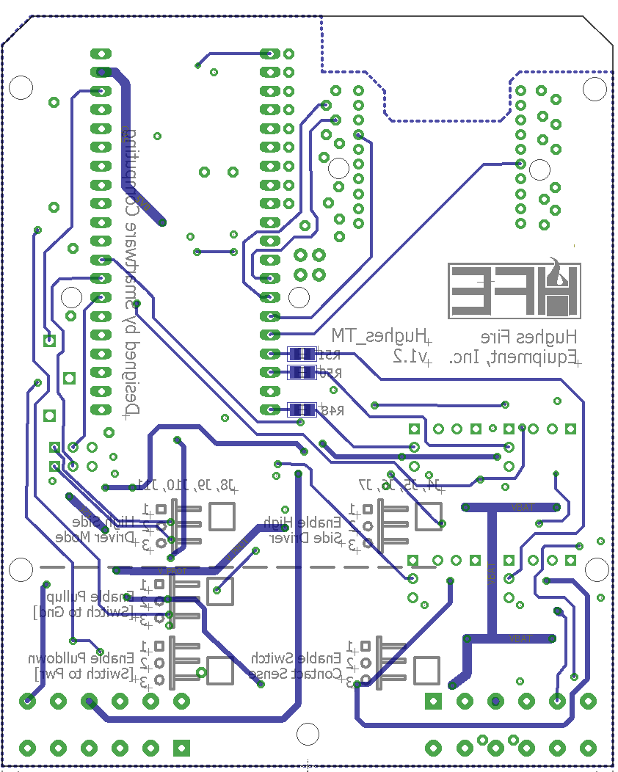

 | Product Details |  | Quantity | Unit Price | Extended Price
15 | 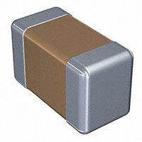 | ‎445-7468-1-ND‎  ‎C1608X5R1H105K080AB‎  TDK Corporation  CAP CER 1UF 50V X5R 0603   | 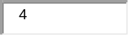 | 0.23000 | $0.92
7 | 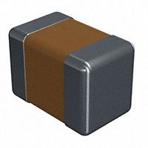 | ‎478-1405-1-ND‎  ‎0805ZC105KAT2A‎  AVX Corporation  CAP CER 1UF 10V X7R 0805   |  | 0.24000 | $0.24
8 | 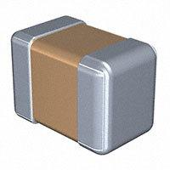 | ‎445-1418-1-ND‎  ‎C2012X7R2A104K125AA‎  TDK Corporation  CAP CER 0.1UF 100V X7R 0805   | 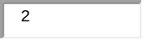 | 0.19000 | $0.38
9 |  | ‎399-1169-1-ND‎  ‎C0805C104M5RACTU‎  KEMET  CAP CER 0.1UF 50V X7R 0805   |  | 0.10000 | $0.20
12 | 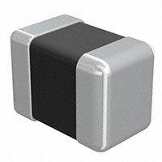 | ‎587-3322-1-ND‎  ‎EMK212BJ105KGHT‎  Taiyo Yuden  CAP CER 1UF 16V X5R 0805   |  | 0.19000 | $0.95
13 |  | ‎399-1163-1-ND‎  ‎C0805C223K5RACTU‎  KEMET  CAP CER 0.022UF 50V X7R 0805  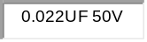 |  | 0.10000 | $0.20
14 |  | ‎399-9155-1-ND‎  ‎C0805C104K9RACTU‎  KEMET  CAP CER 0.1UF 6.3V X7R 0805   |  | 0.24000 | $0.24
59 |  | ‎478-12799-1-ND‎  ‎0805ZD104KAT2A‎  AVX Corporation  CAP CER 0.1UF 10V X5R 0805  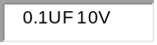 | 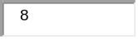 | 0.10000 | $0.80
11 | 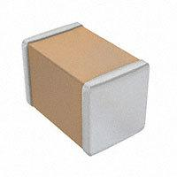 | ‎1276-6687-1-ND‎  ‎CL21A226KQCLRNC‎  Samsung Electro-Mechanics  CAP CER 22UF 6.3V X5R 0805  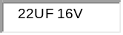 |  | 0.17000 | $0.34
10 | 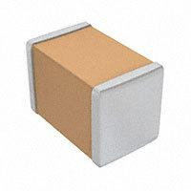 | ‎1276-1075-1-ND‎  ‎CL31A106KAHNNNE‎  Samsung Electro-Mechanics  CAP CER 10UF 25V X5R 1206   |  | 0.24000 | $0.48
6 | 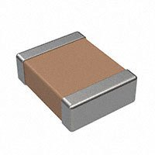 | ‎399-3089-1-ND‎  ‎C1210C474K5RACTU‎  KEMET  CAP CER 0.47UF 50V X7R 1210  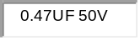 |  | 0.25000 | $0.50
16 | 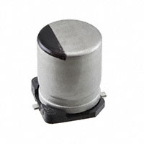 | ‎P121401CT-ND‎  ‎EEH-ZK1V101XP‎  Panasonic Electronic Components  CAP ALUM POLY 100UF 20% 35V SMD   |  | 1.75000 | $3.50
35 | 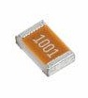 | ‎541-47TACT-ND‎  ‎CRCW080547R0JNEAHP‎  Vishay Dale  RES SMD 47 OHM 5% 1/2W 0805  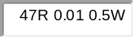 |  | 0.23000 | $0.46
34 | 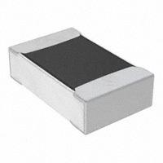 | ‎RNCF0805DTE16K9CT-ND‎  ‎RNCF0805DTE16K9‎  Stackpole Electronics Inc  RES 16.9K OHM 0.5% 1/8W 0805  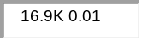 |  | 0.15000 | $0.15
36 |  | ‎RNCP0805FTD49K9CT-ND‎  ‎RNCP0805FTD49K9‎  Stackpole Electronics Inc  RES 49.9K OHM 1% 1/4W 0805  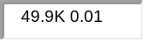 |  | 0.10000 | $0.10
37 | 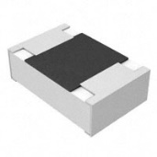 | ‎P13.3KCCT-ND‎  ‎ERJ-6ENF1332V‎  Panasonic Electronic Components  RES SMD 13.3K OHM 1% 1/8W 0805  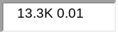 |  | 0.10000 | $0.10
38 |  | ‎RMCF0805FT10K0CT-ND‎  ‎RMCF0805FT10K0‎  Stackpole Electronics Inc  RES 10K OHM 1% 1/8W 0805   | 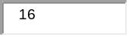 | 0.02600 | $0.42
39 |  | ‎RNCF0805DTE10K0CT-ND‎  ‎RNCF0805DTE10K0‎  Stackpole Electronics Inc  RES 10K OHM 0.5% 1/8W 0805 | 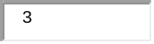 | 0.15000 | $0.45
40 |  | ‎RNCP0805FTD20K0CT-ND‎  ‎RNCP0805FTD20K0‎  Stackpole Electronics Inc  RES 20K OHM 1% 1/4W 0805  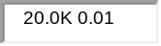 |  | 0.10000 | $0.40
41 |  | ‎RNCP0805FTD39K2CT-ND‎  ‎RNCP0805FTD39K2‎  Stackpole Electronics Inc  RES 39.2K OHM 1% 1/4W 0805  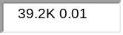 |  | 0.10000 | $0.40
42 |  | ‎RNCP0805FTD15K0CT-ND‎  ‎RNCP0805FTD15K0‎  Stackpole Electronics Inc  RES 15K OHM 1% 1/4W 0805   |  | 0.10000 | $0.20
43 |  | ‎RNCP0805FTD1K50CT-ND‎  ‎RNCP0805FTD1K50‎  Stackpole Electronics Inc  RES 1.5K OHM 1% 1/4W 0805  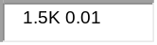 |  | 0.10000 | $0.10
44 |  | ‎P21114CT-ND‎  ‎ERJ-PB6D6801V‎  Panasonic Electronic Components  RES SMD 6.8K OHM 0.5% 1/4W 0805   |  | 0.25000 | $1.00
45 |  | ‎RMCF0805FT249KCT-ND‎  ‎RMCF0805FT249K‎  Stackpole Electronics Inc  RES 249K OHM 1% 1/8W 0805  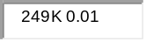 |  | 0.10000 | $0.20
46 | 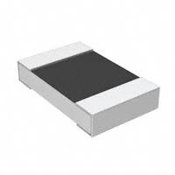 | ‎764-1475-1-ND‎  ‎PTN0805E1113BST1‎  Vishay Thin Film  RES 111K OHM 0.1% 1/5W 0805  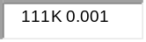 |  | 0.74000 | $0.74
47 |  | ‎RMCF0805FT422RCT-ND‎  ‎RMCF0805FT422R‎  Stackpole Electronics Inc  RES 422 OHM 1% 1/8W 0805  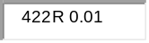 |  | 0.10000 | $0.10
48 | 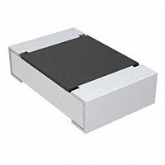 | ‎541-20.0KCCT-ND‎  ‎CRCW080520K0FKEA‎  Vishay Dale  RES SMD 20K OHM 1% 1/8W 0805   |  | 0.10000 | $0.10
49 |  | ‎541-64.9KCCT-ND‎  ‎CRCW080564K9FKEA‎  Vishay Dale  RES SMD 64.9K OHM 1% 1/8W 0805  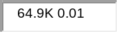 |  | 0.10000 | $0.10
50 |  | ‎P19.6KCCT-ND‎  ‎ERJ-6ENF1962V‎  Panasonic Electronic Components  RES SMD 19.6K OHM 1% 1/8W 0805  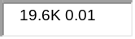 |  | 0.10000 | $0.10
51 |  | ‎RMCF0805FT4K70CT-ND‎  ‎RMCF0805FT4K70‎  Stackpole Electronics Inc  RES 4.7K OHM 1% 1/8W 0805  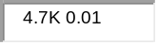 |  | 0.10000 | $0.20
60 |  | ‎RMCF0805FT150RCT-ND‎  ‎RMCF0805FT150R‎  Stackpole Electronics Inc  RES 150 OHM 1% 1/8W 0805   | 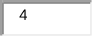 | 0.10000 | $0.40
54 | 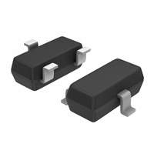 | ‎BSS123LT1GOSCT-ND‎  ‎BSS123LT1G‎  ON Semiconductor  MOSFET N-CH 100V 170MA SOT-23  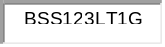 |  | 0.25000 | $0.75
53 | 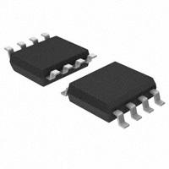 | ‎296-33333-5-ND‎  ‎LP2951D‎  Texas Instruments  IC REG LIN POS ADJ 100MA 8SOIC  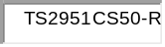 |  | 0.70000 | $0.70
55 | 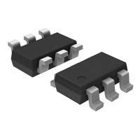 | ‎296-49761-1-ND‎  ‎LMR14010ADDCR‎  Texas Instruments  IC REG BUCK ADJ 1A TSOT23-6  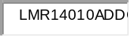 |  | 2.41000 | $4.82
56 | 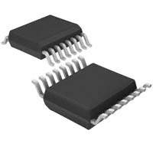 | ‎ADM3101EARQZ-REELCT-ND‎  ‎ADM3101EARQZ-REEL‎  Analog Devices Inc.  IC TRANSCEIVER FULL 1/1 16QSOP  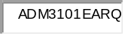 |  | 2.70000 | $2.70
57 |  | ‎DS36277TMX/NOPBCT-ND‎  ‎DS36277TMX/NOPB‎  Texas Instruments  IC TRANSCEIVER HALF 1/1 8SOIC  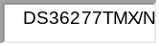 |  | 2.67000 | $2.67
58 | 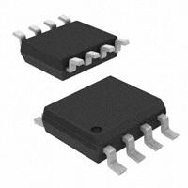 | ‎BTS4175SGAXUMA1CT-ND‎  ‎BTS4175SGAXUMA1‎  Infineon Technologies  IC PWR SWITCH N-CHAN 1:1 DSO-8  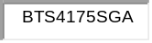 |  | 1.43000 | $5.72
24 |  | ‎296-27602-5-ND‎  ‎SN65HVD252D‎  Texas Instruments  IC TRANSCEIVER HALF 1/1 8SOIC  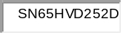 |  | 3.30000 | $6.60
18 | 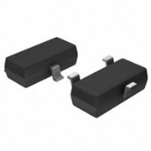 | ‎BAS40-04FDICT-ND‎  ‎BAS40-04-7-F‎  Diodes Incorporated  DIODE ARRAY SCHOTTKY 40V SOT23-3  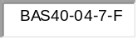 | 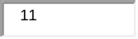 | 0.17900 | $1.97
19 |  | ‎MMBZ5226B-FDICT-ND‎  ‎MMBZ5226B-7-F‎  Diodes Incorporated  DIODE ZENER 3.3V 350MW SOT23-3  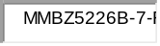 |  | 0.15000 | $0.15
21 | 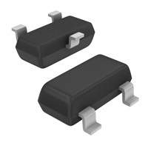 | ‎MMBZ5254BLT1GOSCT-ND‎  ‎MMBZ5254BLT1G‎  ON Semiconductor  DIODE ZENER 27V 225MW SOT23-3  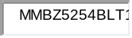 |  | 0.14000 | $0.14
23 |  | ‎NUP2105LT1GOSCT-ND‎  ‎NUP2105LT1G‎  ON Semiconductor  TVS DIODE 24V 44V SOT23-3  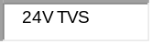 |  | 0.43000 | $0.86
20 | 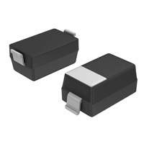 | ‎MBR130T1GOSCT-ND‎  ‎MBR130T1G‎  ON Semiconductor  DIODE SCHOTTKY 30V 1A SOD123  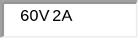 |  | 0.33000 | $0.33
22 | 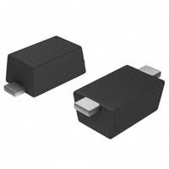 | ‎SS26FLCT-ND‎  ‎SS26FL‎  ON Semiconductor  DIODE SCHOTTKY 60V 2A SOD123F |  | 0.40000 | $0.80
31 | 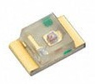 | ‎754-1935-1-ND‎  ‎APT2012LSECK/J3-PRV‎  Kingbright  LED RED CLEAR 2SMD   |  | 0.51000 | $0.51
33 | 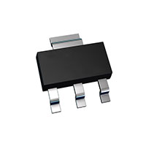 | ‎FZT653CT-ND‎  ‎FZT653TA‎  Diodes Incorporated  TRANS NPN 100V 2A SOT-223  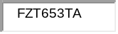 |  | 0.70000 | $0.70
17 | 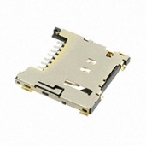 | ‎WM12834CT-ND‎  ‎5031821852‎  Molex  MICRO SD NORMAL ULTRALOWPRO8CKTE   |  | 2.45000 | $2.45
28 | 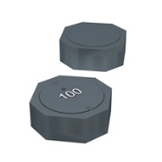 | ‎SRU8043-330YCT-ND‎  ‎SRU8043-330Y‎  Bourns Inc.  FIXED IND 33UH 1.7A 100 MOHM SMD  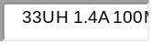 |  | 0.97000 | $0.97
30 | 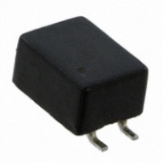 | ‎DR331-513AECT-ND‎  ‎DR331-513AE‎  Bourns Inc.  CMC 51UH 500MA 2LN SMD  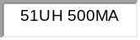 |  | 1.09000 | $2.18
29 | 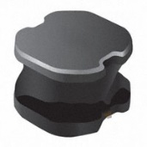 | ‎SRN6045-150MCT-ND‎  ‎SRN6045-150M‎  Bourns Inc.  FIXED IND 15UH 1.9A 95.8MOHM SMD  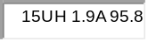 |  | 0.55000 | $0.55
52 | 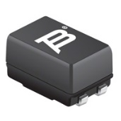 | ‎SRF0905-501YCT-ND‎  ‎SRF0905-501Y‎  Bourns Inc.  CMC 500UH 1A 2LN 1 KOHM SMD  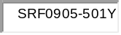 |  | 1.45000 | $1.45
26 | 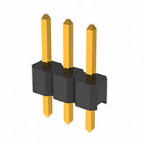 | ‎S1011EC-03-ND‎  ‎PRPC003SAAN-RC‎  Sullins Connector Solutions  CONN HEADER VERT 3POS 2.54MM  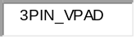 |  | 0.10900 | $1.09
27 | 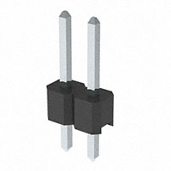 | ‎S1012EC-02-ND‎  ‎PREC002SAAN-RC‎  Sullins Connector Solutions  CONN HEADER VERT 2POS 2.54MM   |  | 0.06000 | $0.12
2 | 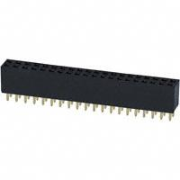 | ‎S7123-ND‎  ‎PPPC202LFBN-RC‎  Sullins Connector Solutions  CONN HDR 40POS 0.1 GOLD PCB  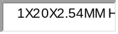 |  | 2.38000 | $4.76
3 | 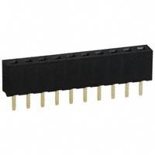 | ‎S5751-10-ND‎  ‎NPPN101BFCN-RC‎  Sullins Connector Solutions  CONN HDR 10POS 0.079 GOLD PCB  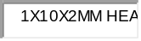 |  | 0.98000 | $1.96
5 | 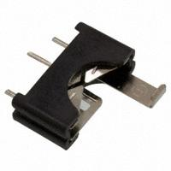 | ‎BS-1225-PC-ND‎  ‎BS-1225-PC‎  MPD (Memory Protection Devices)  BATTERY HOLDER COIN PC PIN  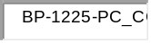 |  | 1.12000 | $1.12
1 | 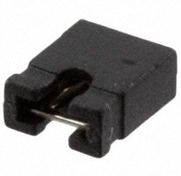 | ‎S9337-ND‎  ‎QPC02SXGN-RC‎  Sullins Connector Solutions  CONN JUMPER SHORTING .100" GOLD  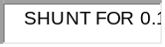 | 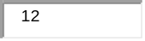 | 0.05900 | $0.71
32 | 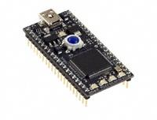 | ‎568-4916-ND‎  ‎OM11043,598‎  NXP USA Inc.  MBED LPC176X DEV EVAL BRD  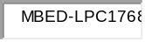 |  | 52.06000 | $52.06
25 | 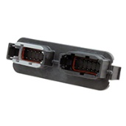 | ‎1734-1131-ND‎  ‎DTM13-12PA-12PB-R008‎  TE Connectivity Deutsch Connectors  CONN HEADER R/A 24POS  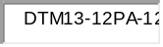 |  | 21.42000 | $21.42
4 | 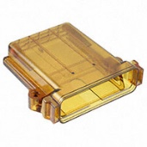 | ‎1734-1061-ND‎  ‎EEC-325X4B-E016‎  TE Connectivity Deutsch Connectors  DTM ENCLOSURE CLR   |  | 28.75000 | $28.75

