Grow Controller Electronics
Marketing may have a great code-name…

General
This document expresses concepts for a one-off prototype, well in advance of final component selection. A production-oriented design would account for the overall features and optionality, and costs would be analyzed more closely based on production in 10’s, 1000’s, and higher quantities as appropriate.

Change History
After initial brainstorming, the document will become “managed”, version controlled, and major updates will be documented. In this section.

Business Aspects

Component Sourcing
For my home projects (which have a build quantity of 1 to 5), I generally favor domestic sourcing, and prices are less of a concern until too significant, then overseas may win out – if an unpredictable 3 to 8-week lead time is acceptable.
Favorite component sourcing sites, approximately in preferential order:
    - Digi-Key
    - Mouser
    - SparkFun
    - Amazon

Electrical Environment Requirements
This section reflects the environment for the electrical / electronic system. The enclosure over the electronics should shield it well from rain and splash and should have cutouts for the front panel controls and indicator.

Regulative Approval
At least these two scenarios likely apply and represent significant unknowns.

UL Approval
Designing for UL approval introduces many unknowns. It is believed that a wholly external power supply (like a laptop supply) places the burden on that supplier. Integrating 120VAC into the device means that this product bears the burden.

FCC Approval
Designing for FCC approval introduces many unknowns, more when wireless communication is involved, such as a Wi-Fi “module”.

Operating Voltage
The device shall plug into a standard 3-wire AC outlet, and be operational within the line voltage range of 90 to 130 VAC. The required current, with all options, is expected to be 5A maximum (~650 W), with all options and the soil heating element active.
Integrated Ground Fault Interrupter, or instructions to plug it in to a GFI protected outlet?

Operating Temperature
Normal operating temperature is limited to the range of 0C to 55C (32F to 130F).

Storage Temperature
Storage temperature (unpowered, non-operating) is defined to the the range of -20C to 70C (-5F to 160F).

Operating Humidity
10 to 90%, non-condensing on the electronics.

Environment
The electronics shall be protected from normal rainfall.
Conformal coating to the PCB may be appropriate for an outdoor device.

Power Supply
Prior experience with this (in my Reflow Oven), It may be overpowered – depending on the motor and pump requirements.
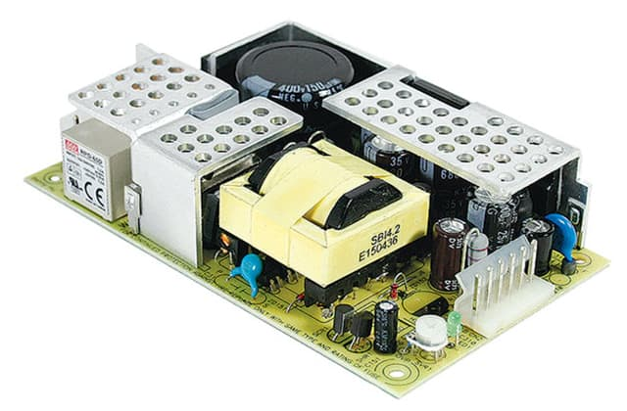 | RPD-65C MEAN WELL USA Inc. | Power Supplies - External/Internal (Off-Board) | DigiKey  12V 4.5A, 5V 1.2A

Motor for drum rotation
The motor and mechanical design shall provide more than enough torque to rotate the drum reliably throughout the operating environmental range.
Ideally, it is not “over-powered” and will torque-limit if a firm or hard obstruction interferes with normal operation of the mechanism.
If not mechanically limited, the motor current with an obstruction should be at least 25% higher than the normal operating current.

Drive Voltage
12 VDC, and in the range of ~0.25-3A nominal.

H-Bridge Driver
Reversible control with H-Bridge Driver. Could reverse slightly on current limit threshold.
May have other uses for reversing.

Current Sensing
Interlock: Stop on over-current / high torque
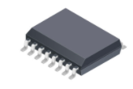 | Analog output  ACS710KLATR-10BB-T Allegro MicroSystems | Sensors, Transducers | DigiKey Marketplace

PCB Interface:
2-pin: H-Bridge for DC Motor

Drum Position Sensing
Consider a hall-sensor with a tiny magnet on the drum, or a microswitch with lever arm.

Drum in Service Position
Command for service access rotates to index point by sensor.
Same position is used for maximum ventilation position.

Drum in Closed Position
Command to minimum ventilation position.

PCB Interface

2 x 3-pin: one for each Hall Sensor position
Future version could integrate hall sensors onto PCB if it is positionally close to the drum.

Front Panel

Power On/Off (cut AC Power)
Cuts the hot side of the AC power.

Button: Move to Service position, Move to Closed Position
Touch to move to service, touch again to move to closed?

Red LED
Indicates service mode and diagnostic blink-codes.

Button: Resume operation
Separate button, or press-hold to resume normal operation

Green LED
Indicates automatic mode.

PCB Interface:
3 to 6-pin: Depending on the panel switch style.

Production Concept
An adhesive backed membrane panel switch with integrated LED appears to be less than ½ the price of discrete switches (with or without LEDs), however the minimum viable quantity may be 500 or more to reach that point. It may be justified at even lower quantity, since this can include other panel graphics, logo, or operating instructions.
Randomly selected site from a web search: JR Panel

Environment Sensing

Soil Temp
Submersible sensor
Operating Range: 0C to 55C (32F to 130F)
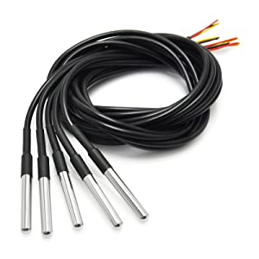 | Protected temp probe like this?  These have a “one-wire” signal interface, which is more complex, so I may want to avoid it due to SW complexity on the micro.  Gikfun DS18B20 Temperature Sensor Waterproof Digital Thermal Probe Sensor for Arduino (Pack of 5pcs) EK1083: Amazon.com: Industrial & Scientific for a 5-pack, or  381 Adafruit Industries LLC | Sensors, Transducers | DigiKey for singles (at a higher price)  Operating temperature range: -55°C to +125°C (-67°F to +257°F,  Accuracy -10°C to +85°C: ±0.5°C,  Cable length: 1 meter

PCB Interface
4-pin: 3-pin for One-wire I/F, 4-in for I2C Temp Sensor

Soil Moisture
I don’t know anything about these.

Research
Inexpensive probes are typically made from a 2-circuit corrosion resistant probe (wire or ENIG PCB traces). One pin is ground and the other has a high-impedance pullup and a voltage measurement is conducted. Contamination/moisture increases the conductance and lowers the voltage.
Thought: Is there value in measuring the capacitance between the probes in addition to the resistance?
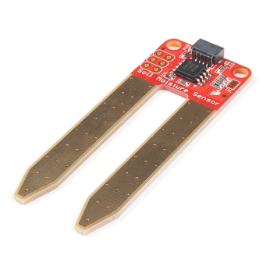 | SparkFun Qwiic Soil Moisture Sensor - SEN-17731 - SparkFun Electronics  SparkFun Soil Moisture Sensor - SEN-13322 - SparkFun Electronics  Soil Moisture Sensor Hookup Guide - learn.sparkfun.com

PCB Interface
X-pin:

Soil pH
Is there value in this measurement, and as a larger challenge, how could it be done inexpensively?

Research
Amazon.com : soil ph meter Inexpensive devices exist on Amazon, but initial research does not reveal “how” the measurement is made, or what the accuracy may be.
pH Sensors - zimmerandpeacock (zimmerpeacocktech.com) This sensor is about $10 in 600 quantities. It isn’t clear w/o more research how to interface to it, however one short video shows using it as a 2-wire sensor. Some not determined electronics converts it to a simple voltage level representing pH.
Possibly buy a cheap one, test it, then do a tear-down.

Enclosure Air Temp
Operating Range: 0C to 55C (32F to 130F)
Without humidity, it could be the same sensor as that used for the soil temperature. If humidity is a desired measurement, then a sensor chip on a small PCB module is appropriate. The actual measurable range is much wider than the anticipated operating range.
Form Factor (for various parts) | Notes
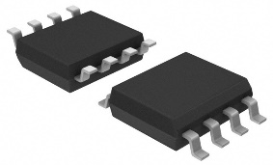 | Simple PCB temp-only sensor  AT30TS74-SS8M-T
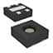 | ENS210-LQFM temp + humidity  $2.67  Tiny, not as much fun in prototype assembly.
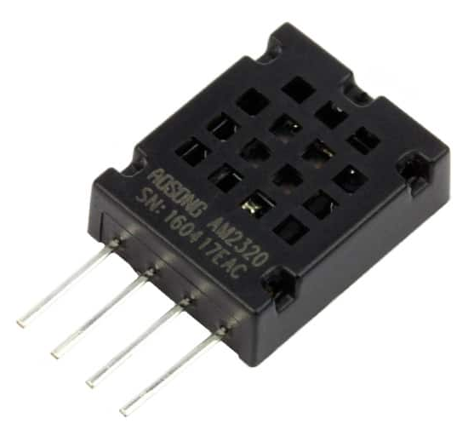 | Simple PCB temp + humidity  $3.90

PCB Interface
4-pin: Same as above

Door open sensing, if not a flexi-net
Hard-wired interlock to cut power to the drum motor, or is the interlock software (sensed motor current turns off the motor)? This probably depends on the stall torque.
If, due to the magic of a mechanical design, the rigid door can only open when the drum is in a specific fixed position, then perhaps a sensor (hall sensor) could be attached to the fixed structure to sense the door is open (magnet on the door).

PCB Interface
2-4-pin: switch or hall sensor

Optional Features

Outside air temp

Direct sensing
0C to 55C (32F to 130F)

PCB Interface
2-4 pin: Use same as one of the prior sensors.

Web Weather
Enter location to pull XML feed.

Water Supply
Water supply control could be either a valve to control a pressurized water source, or a pump with a reservoir.
Assumption is 12VDC for either case. If an alternate component requires 12, 24, or 120 VAC, alternate components are required to manage the power control.

On-off Valve for Pressurized Water supply control
Energize to open the valve. No-power fail-safe to close the valve.

Pump for Reservoir
Assuming 12VDC.

PCB Interface
2-pin: Whether Valve or Motor driven pump.

Low Water Sensor for Reservoir
Magnet on float, reed relay or hall sensor to detect low water. In one concept, if the reed relay can switch the motor current, then sensing no current when the motor is on can reduce the connector and harness complexity.

PCB Interface
3-pin: for Hall Sensor, 2-pin for reed relay.

Enhanced User Interface

Phone Interface
Production goal is for a custom phone interface – android and apple. The impact of this direction should be understood, as the infrastructure and maintenance costs are not trivial.

System Requirements

Embedded Device
The embedded system requires at least the following:
    - Ability to start in Access Point mode, for connection from the phone, ability to scan for available networks, and then assign it to the home network Access Point.
    - Ability to restart into WiFi client mode, connected to the home network.
    - Ability to connect to a cloud server – securely.
    - User accessible switch or button combination to force a restore to factory default, erasing any stored credentials or other access information.

Cloud Server
The cloud server requires at least the following:
    - Secure management of user credentials
    - Secure association of 1 to many devices per user
    - Ability to unassign a single device
    - Ability to query and control a device
    - Secure connection to a client phone app
    - Ability to relay status and command to/from phone and device

Phone Application
The phone application requires at least the following:
    - Secure connection to the cloud server
    - Secure credential management (multifactor authentication?)
    - Ability to connect to the embedded device when in WiFi AP mode
    - Ability to assign embedded device to a home AP

Phone Application
There are “online” application development sites – where requirements are delivered and developers around the globe “bid” on the job. Developers are “rated” by experience. Required deliverables:
    - High level requirements, rather generically to expose as little information as possible.
    - Highly detailed functional specification, possibly obfuscated to the actual application.
    - Requirement for a common codebase for both Android and Apple (compatible with the latest OS version).
    - Full source code and user-guide to reproduce the application.
Concurrently develop the knowledge to post applications into the Google and Apple Stores.

Life-Cycle Maintenance
    - Periodic phone OS updates may require functional changes to the application.
    - Security concerns may require functional changes.

Hosted Web Server Interface
The device, hosting its own web server, can provide a fully capable interface to the user, without the requirement of a custom phone application. This is available from any client (phone, tablet, PC) on the locally hosted network.
This web interface could be exposed to the internet, but this is a non-trivial topic, and misconfiguration could expose the users’ private network to the public internet, so the procedure should not be described in the manual.

Access Security
As a locally hosted environment, on the private network, security could be ignored, or minimally provided with some username-password combinations.

Life-Cycle Maintenance
    - Super-User administrator
    - General Account maintenance – create/expire/purge
    - General Device maintenance – create/expire/purge
    - Data warehouse maintenance / purge
    - Security concerns that require changes
    - Periodic OS updates that may require application changes

User Experience
Whether through a phone or a web interface, the following types of information should be available and configurable – and with presentation style!

Status of all sensors
    - Chamber Temperature
    - Chamber Humidity
    - Soil Temperature
    - Soil Moisture
    - Soil pH
    - Status of Drum
    - Status of Door
    - Motor current during rotation
    - Status of Water Pump or Valve
    - Status of Water Reservoir level
    - Wi-Fi AP Signal Strength

Activation of Service, Normal mode
Should this be permitted since you may not be nearby

Configuration

Temperature Thresholds for Drum Position
Default to factory or override to local settings for temperature thresholds.

Drum over-current threshold
Default to factory or override with some procedure to recalibrate?

Access Point Configuration
    - Ability to scan for available access points. Signal strength of each.
    - Ability to select or enter SSID of an access point.
    - Ability to enter the passcode.
    - Ability to factory reset – clear stored SSID and Passcode

Alert Options
    - Over temperature
    - Low Water
    - Stuck in Service Mode for too long

Process and Wi-Fi
Computing power requirement appear to be modest, but with connectivity and easy field reprogrammability – automatic software update (or manual if the user chooses).

Combined Processor and Wi-Fi module
This is the favored concept, which lowers the overall cost.
The base-unit supports Wi-Fi, and it is a favorite of hobby hackers and professionals alike. It should not be considered highly secure, meaning that hackers can easily find a way to reprogram it with their own code.
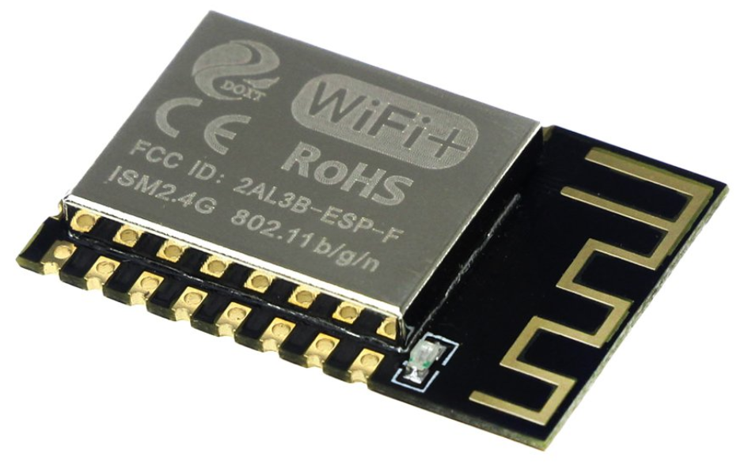 | From overseas sources, these are about $3 in qty 1. Domestically, they are in the range of $6 to $12 per piece.  By itself, this does not have enough IO, so the external A/D and IO expander (in the BOM) are required. There are similar parts with higher IO count that will be considered.  With Wi-Fi integrated, making it “not available” unless they upgrade can be a challenge.

Individual Processor Module and Wi-Fi module
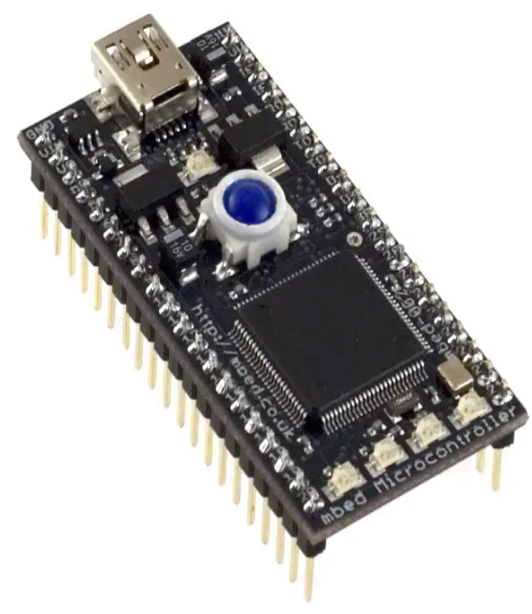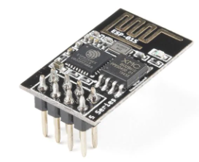 | Alternately, a higher-powered CPU (with more IO) and a separate module for Wi-Fi support. This makes it easier to “add” the Wi-Fi module as an option.  This has an “ease of programming” by plugging it in to any PC and drag-n-drop a new file to it. Alternately, with the Wi-Fi module, it could self-update.  If a production path, it is more likely just the micro (~ $10-15) would be designed rather than the module (~ $55).

IO Expander
In several combinations of host micro and Wi-Fi, there may not be enough IO, so external IO expanders appear in the BOM, as a contingency.

BOM Scenario
A rough BOM was created, based on many assumptions, and quantity 1 (a prototype version). Minor components are not details (screws, small PCB components, etc.) other than as “other parts” guesstimate.

Crazy Ideas
    - Grow Light Control, AC outlet for an external light, timing of the light.

