Grow Controller Electronics
Marketing may have a great code-name…

Document Version 0.1

General
This document expresses concepts for a one-off prototype, well in advance of final component selection. A production-oriented design would account for the overall features and optionality, and costs would be analyzed more closely based on production in 10’s, 1000’s, and higher quantities as appropriate.

Change History
After initial brainstorming, this document shall become “managed” (version controlled), and major updates shall be documented. In this section.
Version | Date | Changes
- | 11 Sep 2021 | Uncontrolled version for review
0.1

Component Sourcing
For my home projects (which have a build quantity of 1 to 5), I generally favor domestic sourcing, and prices are less of a concern until too significant, then overseas may win out – if an unpredictable 3 to 8-week lead time is acceptable.
Favorite component sourcing sites, approximately in preferential order:
    - Digi-Key
    - Mouser
    - SparkFun
    - Amazon

Business Aspects

Functional Options
Just thinking out loud for variants.

Basic Version
The minimum viable product. This may include the Wi-Fi, and integrated Web Server for local access and configuration.

Feature Version
This can include additional features – the heater, moisture sensor, pH sensors, and so on.

Cloud Enabled
This version will connect to the users Wi-Fi Access Point, and from there to a predefined cloud server. This enables remote monitoring and control, as well as the communication of alerts to the user.
This version has a subscription.

Custom Phone Apps
This could be combined with, or independent of, the Cloud Enabled version.

Terminology

Automatic Mode
The operating mode where the unit is automatically controlling the environment.

Automatic Mode Button
The front panel button to activate automatic mode.

Manual Mode
The operating mode where the unit is not operating in the automatic mode.

Manual Mode Button
The front panel button to activate manual mode, or to perform other functions while in manual mode.

Drum Open
The position of the drum where the grow-box is accessible by the user.

Drum Closed
The position of the drum where the grow-box is inaccessible by the user because of the hard-cover position.

Drum Motor
The motor that causes the drum to rotate.

Drum Indexing
The action of operating the Drum Motor until either the Door Open or Door Closed position is reached.

Drum Motor High Current
The setpoint, as measured by current through the drum motor as a reflection of torque, above which the drum rotation is considered obstructed or impaired.

Drum Position Minimum Dwell time
In automatic mode, this is the minimum amount of time in a drum position before drum position rotation command is permitted.

Drum Maximum Travel time
The maximum amount of time, including a margin, that should be required for the Drum to advance from Drum Open to Drum Closed, or from Drum Closed to Drum Open.

Drum Motor Reverse time
The time in which the Drum Motor is reversed to clear any obstruction.

Doorway
The doorway (portal) to access the grow-box, which may be a flexible screen, or a rigid cover that can be opened by the user.

Chamber
The enclosed space above the grow-box.

Chamber Temperature
The ambient temperature in the chamber as measured by a sensor.

Chamber High Temp
The set-point, above which the Drum Open position is commanded.

Chamber Low Temp
The set-point, below which the Drum Closed position is commanded.

Chamber Humidity
The ambient humidity level as measured by a sensor.

Soil Temperature
The soil temperature as measured by a sensor.

Soil Heater
The optional heating element that can be placed in the soil.

Soil Temperature
The soil temperature as measured by a sensor.

Soil High Temp setpoint
The set-point, above which the soil heater is turned off.

Soil Low Temp setpoint
The set-point, below which the soil heater is turned on.

Soil Temperature Alert timeout
The time before an alert if the Soil Temperature is not within the Soil High Temp and Soil Low Temp limits.

Soil Moisture
The measured soil moisture.

Soil Low Moisture setpoint
The Soil Moisture setpoint, below which water should be applied.

Soil pH
The Soil pH, as measured by a sensor.

Water Application Minimum Delay
The minimum amount of time between activations of the watering system.

Water Application Flow Time
The maximum amount of time of activation of the watering system.

Water Valve
A solenoid valve, when energized, permits the flow of water into the soil.

Water Pump
A water pump, when energized, pumps water from a reservoir to the soil.

Water Reservoir Low
A sensor to monitor a water reservoir, to interlock the water pump and for notification of the user.

Communication Option
An optional feature which permits Wi-Fi communications to occur.

Electrical Environment Requirements
This section reflects the environment for the electrical / electronic system. The enclosure over the electronics should shield it well from rain and splash and should have cutouts for the front panel controls and indicator.

Regulative Approval
At least these two scenarios likely apply and represent significant unknowns.

UL Approval
Designing for UL approval introduces many unknowns. It is believed that a wholly external power supply (like a laptop supply) places the burden on that supplier. Integrating 120VAC into the device means that this product bears the burden.

FCC Approval
Designing for FCC approval introduces many unknowns, more when wireless communication is involved, such as a Wi-Fi “module”.

Operating Voltage
The device shall plug into a standard 3-wire AC outlet, and be operational within the line voltage range of 90 to 130 VAC. The required current, with all options, is expected to be 5A maximum (~650 W), with all options and the Soil Heater active.
Integrated Ground Fault Interrupter, or instructions to plug it in to a GFI protected outlet?

Operating Temperature
Normal operating temperature is limited to the range of 0C to 55C (32F to 130F).

Storage Temperature
Storage temperature (unpowered, non-operating) is defined to the range of -20C to 70C (-5F to 160F).

Operating Humidity
10 to 90%, non-condensing on the electronics.

Environment
The electronics shall be protected from normal rainfall.
Conformal coating to the PCB may be appropriate for an outdoor device.

Power Supply
Prior experience with this (in my Reflow Oven), It may be overpowered – depending on the motor and pump requirements.
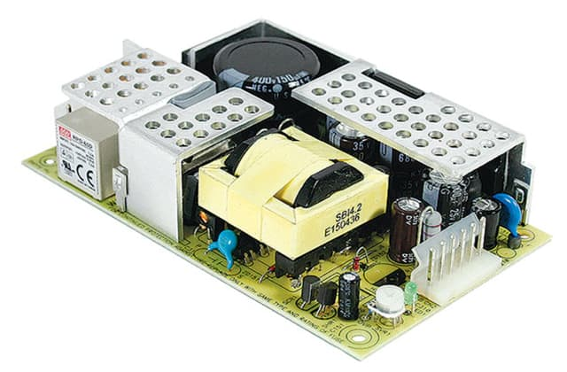 | RPD-65C MEAN WELL USA Inc. | Power Supplies - External/Internal (Off-Board) | DigiKey  12V 4.5A, 5V 1.2A

Motor for drum rotation
The Drum Motor and mechanical design shall ensure more than enough torque to rotate the drum reliably throughout the operating environmental range.
Ideally, it is not “over-powered” and will torque-limit if a firm or hard obstruction interferes with normal operation of the mechanism.
Whether or not mechanically torque limited, the motor current shall be monitored for higher-than-normal operating current.
The mechanical design should ensure that any obstruction impairing drum rotation is be reflected in at least 25% higher than the normal operating current, and even if the motor is not immediately stopped, there should be insufficient torque to damage the mechanism.

Drive Voltage
12 VDC, and in the range of ~0.25-3A nominal.

H-Bridge Driver
Reversible control with H-Bridge Driver.
Will “on-off” operation be sufficient, or should this be PWM controlled to reduce the effective drive current?

Current Sensing
Interlock: Stop on over-current / high torque
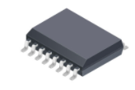 | Analog output  ACS710KLATR-10BB-T Allegro MicroSystems | Sensors, Transducers | DigiKey Marketplace

PCB Interface:
2-pin: H-Bridge for DC Motor

Drum Position Sensing
Hall sensors positioned on the Controller PCB that align with tiny magnets on the drum. The prototype may position the hall sensors off-board.
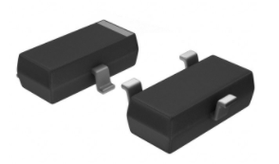 | Hall sensor (many form-factors are available) such as these for $0.30
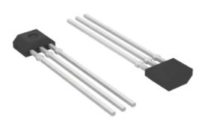 | Or these for $0.50

Drum Open Sensor
The sensor that indicates the Drum is in the open position.

Drum in Closed Position
The sensor that indicates the Drum is in the closed position.

PCB Interface
2 x 3-pin: one for each Hall Sensor.

Front Panel

Power On/Off (cut AC Power)
Cuts the hot side of the AC power.

Button: Move to Service position, Move to Closed Position
Touch to move to service, touch again to move to closed?

Red LED
Indicates Manual Mode, when steady-on and communicates Diagnostic Trouble Codes when blinking.

Button: Resume operation
Separate button, or press-hold to resume normal operation

Green LED
Indicates Automatic Mode.

PCB Interface:
3 to 6-pin: Depending on the panel switch style.

Production Concept
An adhesive backed membrane panel switch with integrated LED appears to be less than ½ the price of discrete switches (with or without LEDs), however the minimum viable quantity may be 500 or more to reach that point. It may be justified at even lower quantity, since this can include other panel graphics, logo, or operating instructions.
Randomly selected site from a web search: JR Panel

Environment Sensing

Soil Temp
Submersible sensor
Operating Range: 0C to 55C (32F to 130F)
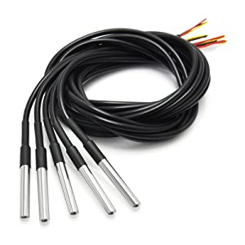 | Protected temp probe like this?  These have a “one-wire” signal interface, which is more complex, so I may want to avoid it due to SW complexity on the micro.  Gikfun DS18B20 Temperature Sensor Waterproof Digital Thermal Probe Sensor for Arduino (Pack of 5pcs) EK1083: Amazon.com: Industrial & Scientific for a 5-pack, or  381 Adafruit Industries LLC | Sensors, Transducers | DigiKey for singles (at a higher price)  Operating temperature range: -55°C to +125°C (-67°F to +257°F,  Accuracy -10°C to +85°C: ±0.5°C,  Cable length: 1 meter

PCB Interface
4-pin: 3-pin for One-wire I/F, 4-in for I2C Temp Sensor

Soil Moisture
I don’t know anything about these.

Research
Inexpensive probes are typically made from a 2-circuit corrosion resistant probe (wire or ENIG PCB traces). One pin is ground and the other has a high-impedance pullup and a voltage measurement is conducted. Contamination/moisture increases the conductance and lowers the voltage.
Thought: Is there value in measuring the capacitance between the probes in addition to the resistance?
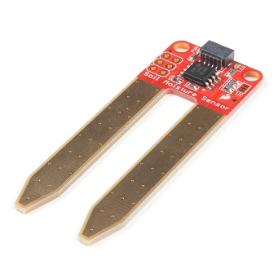 | SparkFun Qwiic Soil Moisture Sensor - SEN-17731 - SparkFun Electronics  SparkFun Soil Moisture Sensor - SEN-13322 - SparkFun Electronics  Soil Moisture Sensor Hookup Guide - learn.sparkfun.com

PCB Interface
X-pin:

Soil pH
Is there value in this measurement, and as a larger challenge, how could it be done inexpensively?

Research
Amazon.com : soil ph meter Inexpensive devices exist on Amazon, but initial research does not reveal “how” the measurement is made, or what the accuracy may be.
Possibly buy a cheap one, test it, then do a tear-down.
Searching for sensors: pH Sensors - zimmerandpeacock (zimmerpeacocktech.com) This sensor is about $10 in 600 quantities. It isn’t clear w/o more research how to interface to it, however one short video shows using it as a 2-wire sensor. Some not detailed electronics convert it to a simple voltage level representing pH.

PCB Interface
x-pin:

Chamber Temperature
Operating Range: 0C to 55C (32F to 130F)
Without humidity, it could be the same sensor as that used for the soil temperature. If humidity is a desired measurement, then a sensor chip on a small PCB module is appropriate. The actual measurable range is much wider than the anticipated operating range.
Form Factor (for various parts) | Notes
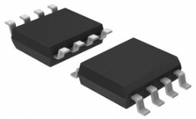 | Simple PCB temp-only sensor  AT30TS74-SS8M-T
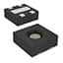 | ENS210-LQFM temp + humidity  $2.67  Tiny, not as much fun in prototype assembly.
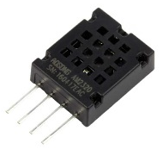 | Simple PCB temp + humidity  $3.90

PCB Interface
4-pin: Same as above

Door open sensing, if not a flexi-net
Hard-wired interlock to cut power to the drum motor, or is the interlock software (sensed motor current turns off the motor)? This probably depends on the stall torque.
If, due to the magic of a mechanical design, the rigid door can only open when the drum is in a specific fixed position, then perhaps a sensor (hall sensor) could be attached to the fixed structure to sense a magnet on the door.

PCB Interface
2-4-pin: switch or hall sensor

Optional Features

Outside air temp

Direct sensing
0C to 55C (32F to 130F)

PCB Interface
2-4 pin: Use same as one of the prior sensors.

Web Weather
Enter location to pull XML feed.

Water Supply
Water supply control could be either a valve to control a pressurized water source, or a pump with a reservoir.
Assumption is 12VDC for either case and that both are not required.
If an alternate actuator requires AC; 12, 24, or 120, the electronic design will be revised to adapt.

On-off Valve for Pressurized Water supply control
Energize to open the valve. No-power should auto-close the valve.

Pump for Reservoir
Assuming 12VDC.

PCB Interface
2-pin: Whether Valve or Motor driven pump.

Low Water Sensor for Reservoir
Magnet on float, reed relay or hall sensor to detect low water. In one concept, if the reed relay can switch the motor current, then sensing no current when the motor is on can reduce the connector and harness complexity.

PCB Interface
3-pin: for Hall Sensor, 2-pin for reed relay.

Enhanced User Interface

Phone Interface
Production goal is for a custom phone interface – android and apple. The impact of this direction should be understood, as the infrastructure and maintenance costs are not trivial.

System Requirements

Embedded Device
The embedded system requires at least the following:
    - Ability to start in Access Point mode, for connection from the phone, ability to scan for available networks, and then assign it to the home network Access Point.
    - Ability to restart into Wi-Fi client mode, connected to the home network.
    - Ability to connect to a cloud server – securely.
    - User accessible switch or button combination to force a restore to factory default, erasing any stored credentials or other access information.

Cloud Server
The cloud server requires at least the following:
    - Secure management of user credentials
    - Secure association of 1 to many devices per user
    - Ability to unassign a single device
    - Ability to query and control a device
    - Secure connection to a client phone app
    - Ability to relay status and command to/from phone and device

Phone Application
The phone application requires at least the following:
    - Secure connection to the cloud server
    - Secure credential management (multifactor authentication?)
    - Ability to connect to the embedded device when in Wi-Fi AP mode
    - Ability to assign embedded device to a home AP

Phone Application
There are “online” application development sites – where requirements are delivered and developers around the globe “bid” on the job. Developers are “rated” by experience.
I suggest we obfuscate the product:
    - Deliver High level requirements, rather generically to expose as little information as possible.
    - Then deliver Highly detailed functional specifications, probably obfuscated to the actual application.
    - Requirement for a common codebase for both Android and Apple (compatible with the latest OS version).
    - Full source code and user-guide to reproduce the application.
Concurrently develop the knowledge to post applications into the Google and Apple Stores.

Life-Cycle Maintenance
    - Periodic phone OS updates may require functional changes to the application.
    - Security concerns may require functional changes.

Hosted Web Server Interface
The device, hosting its own web server, can provide a fully capable interface to the user, without the requirement of a custom phone application. This is available from any client (phone, tablet, PC) on the locally hosted network.
This web interface could be exposed to the internet, but this is a non-trivial topic, and misconfiguration could expose the users’ private network to the public internet, so the procedure should not be described in the manual.

Access Security
As a locally hosted environment, on the private network, security could be ignored, or minimally provided with some username-password combinations.

Life-Cycle Maintenance
    - Super-User administrator
    - General Account maintenance – create/expire/purge
    - General Device maintenance – create/expire/purge
    - Data warehouse maintenance / purge
    - Security concerns that require changes
    - Periodic OS updates that may require application changes

User Experience
Whether through a phone or a web interface, the following types of information should be available and configurable – and with presentation style!

Status of all sensors
    - Chamber Temperature
    - Chamber Humidity
    - Soil Temperature
    - Soil Moisture
    - Soil pH
    - Status of Drum
    - Status of Door
    - Motor current during rotation
    - Status of Water Pump or Valve
    - Status of Water Reservoir level
    - Wi-Fi AP Signal Strength

Activation of Service, Normal mode
Should this be permitted since you may not be nearby

Configuration

Temperature Thresholds for Drum Position
Default to factory or override to local settings for temperature thresholds.

Drum over-current threshold
Default to factory or override with some procedure to recalibrate?

Access Point Configuration
    - Ability to scan for available access points. Signal strength of each.
    - Ability to select or enter SSID of an access point.
    - Ability to enter the passcode.
    - Ability to factory reset – clear stored SSID and Passcode

Alert Options
    - Over temperature
    - Low Water
    - Stuck in Service Mode for too long

Processor and Wi-Fi
Computing power requirement appear to be modest, but with connectivity and easy field reprogrammability – automatic software update (or manual if the user chooses).

Combined Processor and Wi-Fi module
This is the favored concept, which lowers the overall cost.
The base-unit supports Wi-Fi, and it is a favorite of hobby hackers and professionals alike. It should not be considered highly secure, meaning that hackers can easily find a way to reprogram it with their own code.
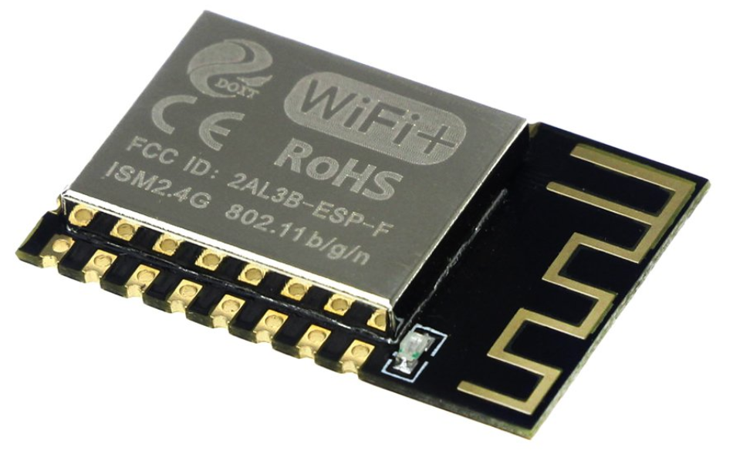 | From overseas sources, these are about $3 in qty 1. Domestically, they are in the range of $6 to $12 per piece.  By itself, this does not have enough IO, so the external A/D and IO expander (in the BOM) are required. There are similar parts with higher IO count that will be considered.  With Wi-Fi integrated, making it “not available” unless they upgrade can be a challenge.

Individual Processor Module and Wi-Fi module
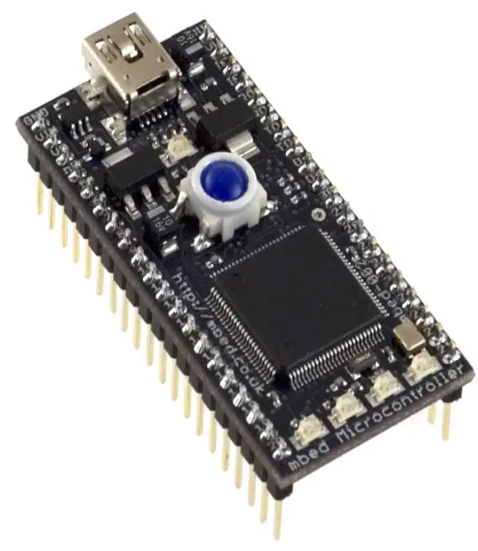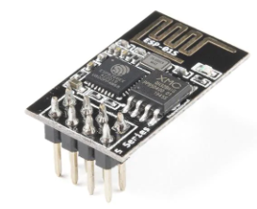 | Alternately, a higher-powered CPU (with more IO) and a separate module for Wi-Fi support. This makes it easier to “add” the Wi-Fi module as an option.  This has an “ease of programming” by plugging it in to any PC and drag-n-drop a new file to it. Alternately, with the Wi-Fi module, it could self-update.  If a production path, it is more likely just the micro (~ $10-15) would be designed rather than the module (~ $55).

IO Expander
In several combinations of host micro and Wi-Fi, there may not be enough IO, so external IO expanders appear in the BOM, as a contingency.

BOM Scenario
A rough Bill of Materials (BOM) was created, based on many assumptions, for quantity 1 (a prototype version). Many minor components are not detailed (screws, small PCB components, overlooked items, etc.). This is done to provide an initial “guesstimate”. In quantity closer to 1000s, the BOM cost may reduce by 50% (also a guesstimate).

Embedded Controller Requirements
This section defines the embedded controller requirements.

Non-Volatile Settings
Each non-volatile setting also has a factory default value in permanent memory. A method shall exist to overwrite the non-volatile settings with the factory default.
Cross reference these against the other requirements to ensure all are accounted for.

Drum Motor High Current threshold
Probably in steps of 0.1A.
Factory Default: X.Y A

Drum Position Minimum Dwell time
Number of seconds, from 0 to 3600.
Factory Default: 120

Drum Motor Reverse time
Number of seconds in tenths, from 0 to 10.0.
Factory Default: 0.5

Chamber High Temp setpoint
Degrees – 45 to 140F
Factory Default: 100

Chamber Low Temp setpoint
Degrees – 45 to 140F
Factory Default: 70

Chamber Temperature Alert timeout
Number of minutes, from 0 to 240.
Factory Default: 15

Soil High Temp setpoint
Degrees – 45 to 140F
Factory Default: 70

Soil Low Temp setpoint
Degrees – 45 to 140F
Factory Default: 60

Soil Temperature Alert timeout
Number of minutes, from 0 to 240.
Factory Default: 15

Wi-Fi Access Point SSID
The Wi-Fi Service Set Identifier (SSID) field shall accept up to 32 characters. The IEEE standard permits any UTF-8 character, however some may be excluded from entry, such as <CR>.
Factory Default: Null

Wi-Fi Access Point Passcode
The Wi-Fi passcode field, aligned to the IEEE standard, shall accept from 8 to 63 ASCII encoded characters.

Power-up Mode
0 = Power up in Manual Mode.
1 = Power up in Automatic Mode.
2 = Power up in the last operating mode before the power loss.

Last Operating Mode
0 = Manual Mode.
1 = Automatic Mode.

Manual Mode
These requirements define the behavior when operating in the Manual Mode, meaning that the user is, or was, interacting locally, and did not change it to Automatic Mode.
The red LED on the front panel shall be on, indicating Manual Mode and the green LED shall be off.
In the Manual Mode Button is pressed, Drum Indexing shall be activated.
If the user presses the Automatic Mode Button on the front panel, the unit shall switch to the Automatic Mode with the Drum Position Minimum Dwell time expired.

Automatic Mode
These requirements define the behavior when operating in the Automatic Mode, meaning that the user is not locally, or remotely, interacting with the appliance.
If the user presses the Manual Mode Button on the front panel:
    - The unit shall switch to Manual Mode.
    - The Drum Position Minimum Dwell time shall be set to expired.

Chamber Climate Control
If the Chamber Temperature goes above the Chamber High Temp setpoint, and if the Drum position is Drum Closed, and if the Drum Position Minimum Dwell time has expired, Drum Indexing shall be activated to advance to the Drum Open position.
If the Chamber Temperature remains above the Chamber High Temp setpoint for more than Chamber Temperature Alert timeout:
- The Diagnostic Trouble Code for Chamber Temperature Hot Alert is set.
- A Diagnostic Trouble Code shall be activated on the front panel.
- If the Communication Option is enabled, the user shall be notified.
If the Chamber Temperature goes below the Chamber Low Temp setpoint, and if the Drum position is Drum Open, and if the Drum Position Minimum Dwell time has expired, Drum Indexing shall be activated to advance to the Drum Closed position.
If the Chamber Temperature remains below the Chamber Low Temp setpoint for more than Chamber Temperature Alert timeout:
- The Diagnostic Trouble Code for Chamber Temperature Cold Alert is set.
- A Diagnostic Trouble Code shall be activated on the front panel.
- If the Communication Option is enabled, the user shall be notified.
If the Chamber Temperature is above the Chamber Low Temp setpoint, and below the Chamber High Temp setpoint, the Diagnostic Trouble Code is cleared.

Soil Climate Control
If the Soil Temperature goes above the Soil High Temp setpoint, and if the Soil Heater is active, the Soil Heater shall be deactivated.
If the Soil Temperature remains above the Soil High Temp setpoint longer than the Soil Temperature Alert timeout:
- The Diagnostic Trouble Code for Soil Temperature Hot Alert is set.
- A Diagnostic Trouble Code shall be activated on the front panel.
- If the Communication Option is enabled, the user shall be notified.
If the Soil Temperature goes below the Soil Low Temp setpoint, and if the Soil Heater is inactive, the Soil Heater shall be activated.
If the Soil Temperature remains below the Soil Low Temp setpoint longer than the Soil Temperature Alert timeout:
- The Diagnostic Trouble Code for Soil Temperature Cold Alert is set.
- A Diagnostic Trouble Code shall be activated on the front panel.
- If the Communication Option is enabled, the user shall be notified.
If the Soil Temperature is above the Soil Low Temp setpoint, and below the Soil High Temp setpoint, the Diagnostic Trouble Code is cleared.

Water Control
Water Control could be accomplished with a Water Valve, or with a Water Pump. The design could accommodate either of these (if they both use a 12V valve/pump).
If we choose to support both, then there needs to be a way to determine which has been selected.
What should the algorithm be? This area needs significant work.

Water Valve Control
If the Soil Moisture is below the Soil Low Moisture setpoint, and if the Water Application Minimum Delay has expired, then the Water Valve is activated for Water Application Flow Time.

Water Pump Control
If the Soil Moisture is below the Soil Low Moisture setpoint, and if the Water Reservoir Low is not active, and if the Water Application Minimum Delay has expired, then the Water Pump is activated for Water Application Flow Time.
If the Water Reservoir Low is activated:
- Set the Diagnostic Trouble Code for Water Reservoir Low.
- A Diagnostic Trouble Code shall be activated on the front panel.
- If the Communication Option is enabled, the user shall be notified.

Drum Motor Current Monitor
Under all operating conditions when Drum Indexing is active, the motor current is monitored.
For any direction of rotation of the motor, if the Drum Motor High Current threshold is reached or exceeded:
- The Drum Motor direction shall be reversed for Drum Motor Reverse time and then deactivated to permit easy removal of any possible obstruction.
- If it was in Automatic Mode, the Operating Mode shall change to Manual Mode.
- Set the Diagnostic Trouble Code for Drum Motor Overcurrent.
- A Diagnostic Trouble Code shall be activated on the front panel.
- If the Communication Option is enabled, the user shall be notified.
If the operator presses any button on the front panel, the Diagnostic Trouble Code is cleared.

Drum Indexing
Anytime the Drum Motor is in operation, the system monitors the indexing progress.
When the position sensors indicate the next position is reached, the Drum Motor shall be turned off and Drum Indexing is then complete.
If the unit is in Automatic Mode, the Drum Position Minimum Dwell time shall be reset, to prevent further drum position changes until the timer has expired.
If the unit is in Manual Mode, the Drum Position Minimum Dwell time shall be set to the expired value.
If a valid position is not sensed within the Drum Maximum Travel time in the transition to Drum Open the Drum Motor shall be deactivated, and the following actions shall be performed:
- When the unit is in Automatic Mode, the Operating Mode shall change to Manual Mode.
- Set the Diagnostic Trouble Code, for Drum Open Position Not Reached in Allowed Time.
- A Diagnostic Trouble Code shall be activated on the front panel.
- If the Communication Option is enabled, the user shall be notified.
If a valid position is not sensed within the Drum Maximum Travel time in the transition to Drum Closed the Drum Motor shall be deactivated, and the following actions shall be performed:
- When the unit is in Automatic Mode, the Operating Mode shall change to Manual Mode.
- Set the Diagnostic Trouble Code, for Drum Closed Position Not Reached in Allowed Time.
- A Diagnostic Trouble Code shall be activated on the front panel.
- If the Communication Option is enabled, the user shall be notified.

Diagnostic Trouble Code

When a Diagnostic Trouble Code is active, the front panel red LED shall blink the code. The code is a sequence of flashes representing the numeric digit(s). One fast flash and a pause for the value ‘1’, two fast flashes and a pause for the value ‘2’ and so on.
If there is a reason to support more than one digit, there shall be a long pause between each digit sequence.
If two or more Diagnostic Trouble Codes are active, each code could be flashed in sequence, followed by an extra long pause before the sequence restarts.

Diagnostic Trouble Code Software Design
The set of DTCs exist as a bit-array. In general, the software that can activate (set) a DTC shall also be responsible for deactivating (clearing) it.
Each bit may have an associated DTC number, which permits grouping (e.g., Drum Motor codes may be 10, 11, 12, …, and then Water Pump may be 20, 21, …).

Diagnostic Trouble Code List
The following Diagnostic Trouble Codes are defined.
Cross reference each of these to the requirements above to ensure coverage.

Drum Motor Overcurrent
The Drum Motor current exceeded the defined maximum, indicating a possible obstruction that prevents proper rotation.
User Action: Turn power off and check the drum for any obstruction that may be preventing proper rotation. Remove the obstruction and turn the power back on.

Drum Open Position Not Reached in Allowed Time
The Drum did not reach the Drum Open position within the Allowed Time, indicating a possible obstruction, or slippage of the Drive Motor.
User Action: Turn power off and check the drum for any obstruction that may be preventing proper rotation. Remove the obstruction and turn the power back on. Alternately, ensure that the Door Open magnet is in position.

Drum Closed Position Not Reached in Allowed Time
The Drum did not reach the Drum Closed position within the Allowed Time, indicating a possible obstruction, or slippage of the Drive Motor.
User Action: Turn power off and check the drum for any obstruction that may be preventing proper rotation. Remove the obstruction and turn the power back on. Alternately, ensure that the Door Closed magnet is in position.

Chamber Temperature Cold Alert
The Chamber temperature went below the expected minimum temperature for more than the Chamber Temperature Alert timeout.
User Action: Check the environmental temperature surrounding the Grow Chamber, move the Grow Chamber to a warmer environment.

Chamber Temperature Hot Alert
The Chamber temperature went above the expected maximum temperature for more than the Chamber Temperature Alert timeout.
User Action: Check the environmental temperature surrounding the Grow Chamber, move the Grow Chamber to a cooler environment.

Soil Temperature Cold Alert
The Soil temperature went below the expected minimum temperature for more than the Soil Temperature Alert timeout.
User Action: Check the environmental temperature surrounding the Grow Chamber, move the Grow Chamber to a warmer environment.
User Action: Check the Soil Heater for failure. Replace the Soil Heater if necessary.

Soil Temperature Hot Alert
The Soil temperature went above the expected maximum temperature for more than the Soil Temperature Alert timeout.
User Action: Check the environmental temperature surrounding the Grow Chamber, move the Grow Chamber to a cooler environment.
User Action: Check the Soil Heater for failure. If the Heater is on (hot), replace the Grow Controller.

Water Reservoir Low Alert
The Water Reservoir sensor indicates the reservoir should be refilled.
User Action: Check the water reservoir level and refill it.

Crazy Ideas
Crazy ideas go here. Most may not make the cut to be included, but they can at least be rationalized as out of scope.
    - Grow Light Control, AC outlet for an external light, timing of the light.
    - Auxiliary Electrical Outlet – for who knows what?
    - Are 2 front panel buttons enough?
    - Reset Wi-Fi settings
    - Reset to Factory settings
    - Manually Activate Water Pump or Water Valve?

